

AGENDA
Wednesday July 19, 2023 7:00 p.m. via Zoom

1. | Welcome and Introductions | Chair | 7:00 p.m.
2. | Approval of June Minutes | Council | 7:02 p.m.
3. | Public Comment | Public | 7:04 p.m.

Council Business:
1. | Update on Connecticut Public Transportation Council Membership | CDOT | 7:10 p.m.
2. | Actions Taken to Date re: CTPTC | CDOT | 7:20 p.m.
3. | Future Steps RE: CTPTC | CDOT | 7:30 p.m.
4. | Rail Operations Report Review | CDOT | 8:15 p.m.
5. | Bus Operations Report Review | CDOT | 8:25 p.m.
6. | Old Business / New Business | Council | 8:35 p.m.
7. | Adjourn | Council | 8:40 p.m.

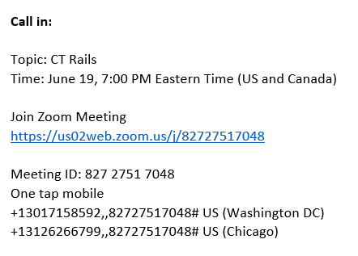

Next Meeting
August 16, 2023
T.B.D.

