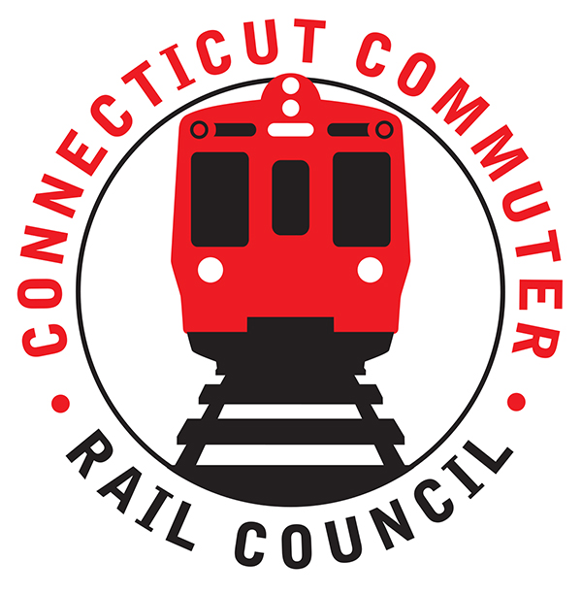

**Connecticut Commuter Rail Council**

**Minutes: Wednesday March 16, 2023 7:00 p.m.**

**via Zoom**

The following Councilmembers were in attendance: Zell Steever, Doug Hausladen, Julia McGrath, Sue Prosi, Frank Petise for Mayor Caroline Simmons, Kate Rozen, Jim Gildea, Gregory Burnes, and Blaize Levitan.

Also in attendance:

Representatives of CTDOT and MNR.

**Council Business**:

Chairman Gildea called the meeting called to order at 7:05pm.

The February meeting minutes were moved for approval by Zell Steever and seconded by Kate Rozen. The minutes approved unanimously.

**Public Comments**:

Miriam Grossman: The Hartford Union Station and Hartford Line schedule needs attention with regards to signage, concessions, and bathrooms. Late night services, especially DASH is lacking. CTDOT has no late-night service. Customer Experience of CTDOT is lacking. New London station service and connectivity is lacking.

**Customer Experience Effort Update**

Alicia Leite provided an update on the Customer Experience Action Plan. See attached PPT. Councilmembers had a Q&A session on the CX Action Plan update.

**New Canaan Branch Service Work**

Dan Baker CTDOT and Mike Loney MNR provided an update on the New Canaan branch work. See press release: <https://portal.ct.gov/DOT/CTDOT-Press-Releases/2023/Upcoming-Track-Improvements-on-the-Metro-North-New-Canaan-Branch-Line>

Q&A with Councilmembers regarding the proposed work.

**Data Update**

Chair Gildea provided an update on the basic data requests the Council made of CTDOT on February 11, 2022. CTDOT still does not have on-time performance by major station, ridership data by major station, or crime statistics by station. Chair Gildea said that CTDOT said that they are working with MTA PD to get the crime data. Ben Cornelius of MNR said that they are working on getting CTDOT the OTP by major station. Ben emphasized that they are a contractor of CTDOT.

**Main Line Issues**

Ben Cornelius of MNR said that MNR was the highest rated service of the MTA and had an overall satisfaction rating of 89%. Ben said that he has been happy with operations over the past few months. Ben explained that the express service doesn’t take passengers at Stamford because of concerns about too many riders and Stamford has many express services, but they would look at it if CTDOT asked.

**Other Lines**

No issues or questions. Chair Gildea pointed out the growing ridership on SLE and the fact that last month, SLE was within 12% of the Danbury line, which is at 100% of pre-COVID service while SLE is held at 66% of pre-COVID service.

**Legislative Update**

Kate Rozen provided an update on the legislative initiatives of the Council and major transportation items. See attached. Councilmembers are feeling hopeful for the restoration of SLE.

**Adjournment**

Moved by Doug Hausladen and Seconded by Zell Steever. Meeting was adjourned by unanimous vote at 8:19PM with a note of another meeting following ours.

Respectfully submitted,

Blaize Levitan, Secretary