

AGENDA
Wednesday May 17, 2023 7:00 p.m. via Zoom

1. | Welcome and Introductions | Chair | 7:00 p.m.
2. | Approval of April 2023 Minutes | Council | 7:02 p.m.
3. | Public Comment | Public | 7:04 p.m.

Council Business:
1. | Impact of 86% service on NHL and 40% on SLE | CDOT | 7:10 p.m.
2. | Express Trip Ridership Data | CDOT | 7:30 p.m.
3. | Update Project No. 300-214 TIME-1 and the Increase the Maximum Authorized Speed) in the cities of Bridgeport to Stratford from 70 mph to 90 mph | CDOT | 7:40 p.m.
4. | Main Line Issues | CDOT | 8:05 p.m.
5. | Branches, Hartford Line and Shoreline Issues | CDOT | 8:15 p.m.
6. | Legislative Update | Council | 8:20 p.m.
7. | Old Business / New Business | Council | 8:30 p.m.
8. | Adjourn | Council | 8:40 p.m.

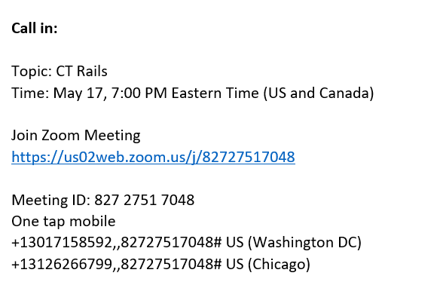

Next Meeting
June 21, 2023
T.B.D.

