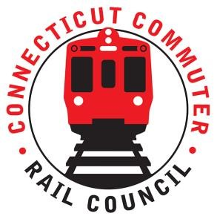

AGENDA

Wednesday, April 29, 2023 – 6:00 PM
Metro North Conference Room Graybar Building 10A
Grand Central Terminal
420 Lexington Avenue
New York, NY

1. | Welcome and Introductions | Chair | 6:00 p.m.
2. | Approval of March 2023 Minutes | Council | 6:02 p.m.
3. | Public Comment | Public | 6:04 p.m.

Council Business:
1. | East Side Access project update | MNR | 6:10 p.m.
2. | Customer service update | MNR | 6:30 p.m.
3. | CCRC Operational Metric Request | CDOT | 7:00 p.m.
4. | Main Line / Branch line Issues | CDOT | 7:15 p.m.
5. | Hartford Line and Shoreline Issues | CDOT | 7:20 p.m.
6. | Legislative Update | Council | 7:30 p.m.
7. | Adjourn | Council | 7:40 p.m.

Zoom:
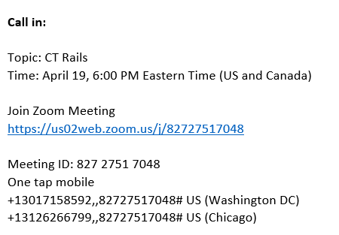

Next Meeting
May 18, 2022
T.B.D.

