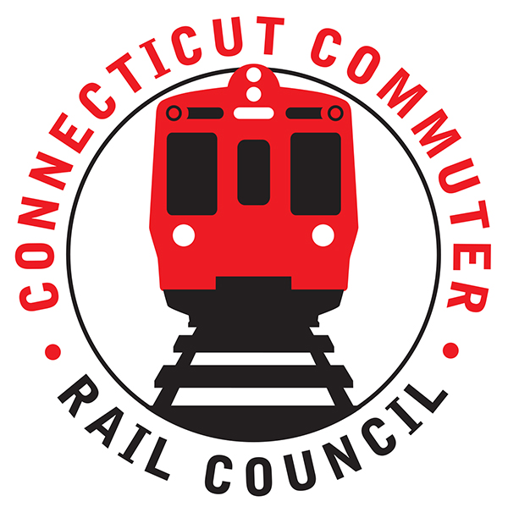

**Connecticut Commuter Rail Council**

**Minutes: Wednesday May 4, 2023 6:00 p.m.**

**via Grand Central Station & Zoom**

The following Councilmembers were in attendance: Zell Steever, Doug Hausladen, Julia McGrath, Sue Prosi, Frank Petise for Mayor Caroline Simmons, Kate Rozen, Jim Gildea, Gregory Burnes, and Blaize Levitan.

Also in attendance:

Representatives of CTDOT and MNRR.

**Council Business**:

Chairman Gildea called the meeting called to order at 6:04pm.

The February meeting minutes were moved for approval by Doug Hausladen and seconded by Zell Steever. The minutes approved unanimously.

MNRR couldn’t provide a tour of the new East Side Access tunnel and Grand Central Madison, but offered to reschedule.

**Public Comments**:

There was no public comment.

**East Side Access Update**

MNRR provided a detailed update on the East Side Access project. See attached presentation.

**MNRR Customer Service Satisfaction Update**

Samantha Hawkins of MNRR presented the results of the customer satisfaction survey Fall 2022. See attached. Questions and answers with Council Members and staff. Council Member Doug H will share the results of the Union Station daily surveys conducted by kiosk.

**Data Request Update**

Chair Gildea provided an update on the basic data requests the Council made of CTDOT on February 11, 2022. CTDOT still does not have on-time performance by major station, ridership data by major station, or crime statistics by station. Ben Cornelius of MNRR wanted to know why the Council wanted the data. Chair Gildea and Council Member Blaize Levitan emphasized that CCRC needs the data to evaluate how the service is performing for the CT-based commuter. There is no one looking out for the intrastate-CT commute. Ben said that they can work on getting OTP by major station. Passenger volume by station is not currently possible, but they may be able to get ticket sales by station. Ben emphasized that they are a contractor of CTDOT, and CTDOT has never asked for this data.

Chair Gildea will schedule a meeting with Ben C and Blaize L.

**Main Line Issues**

Council Members questioned MNRR if the current schedule design fits with changing ridership patterns, including higher off-peak travel. MNRR said they are monitoring, but no changes at this time.

**Other Lines**

Council Members expressed continued frustration with the challenging Shore Line East reduced schedule and poor schedule design. CTDOT was unclear about what actions are being taken to return the THRU express service or similar concept.

CTDOT said there are upcoming service outages expected for SLE for track work.

**Legislative Update**

Kate Rozen provided an update on the legislative initiatives of the Council and major transportation items. See attached.

**Adjournment**

Moved by Doug Hausladen and Seconded by Zell Steever. Meeting was adjourned by unanimous vote at 7:28PM.

Respectfully submitted,

Blaize Levitan, Secretary