

AGENDA
Wednesday March 15, 2023 7:00 p.m. via Zoom

1. | Welcome and Introductions | Chair | 7:00 p.m.
2. | Approval of March 2023 Minutes | Council | 7:02 p.m.
3. | Public Comment | Public | 7:04 p.m.

Council Business:
1. | Customer Service CX Efforts | CDOT | 7:10 p.m.
2. | New Canaan Branch Work Update & Schedule Impact | CDOT | 7:40 p.m.
3. | CCRC Data Request Status Update | CDOT | 7:50 p.m.
4. | Main Line Issues | CDOT | 8:05 p.m.
5. | Branches, Hartford Line and Shoreline Issues | Council | 8:15 p.m.
6. | Legislative Update | Council | 8:20 p.m.
7. | Old Business / New Business | Council | 8:30 p.m.
8. | Adjourn | Council | 8:40 p.m.

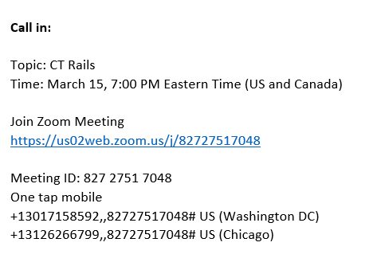

Next Meeting
April 19, 2023
T.B.D.

