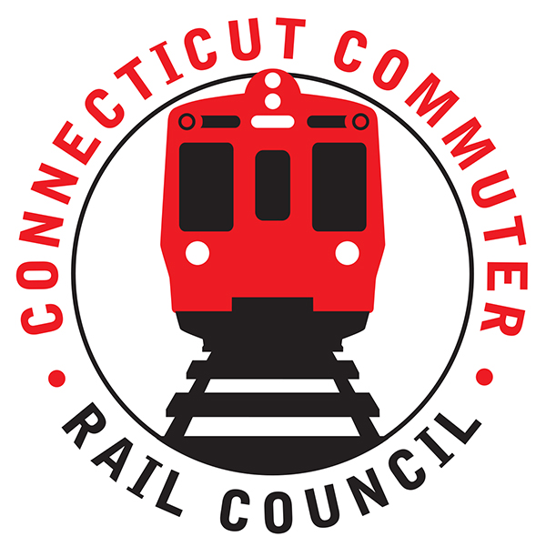

**Connecticut Commuter Rail Council**

**Minutes: January 18, 2022 6:00 p.m.**

**Via Hartford Transit District Conference Room**

The following Councilmembers were in attendance: Zell Steever, Doug Hausladen, Julia McGrath, Marcellus Edwards, Melissa Kane, and Kate Rozen, and Jim Gildea. The Council was joined by representatives from CDOT, TASI, Amtrak, and MetroNorth.

**Council Business**:

Chairman Gildea called the meeting called to order at 6:05pm.

The November meeting minutes were moved for approval by Doug Hausladen and seconded by Zell Steever. The minutes approved unanimously.

**Public Comments**:

Miriam Grossman: Hartford station restrooms remain in poor condition, there is poor bus service connections with HL service, there are no late-night bus services to connect events and games with the train, there is no late night train service on the Hartford Line. In addition, problems with the third party transit app this month, it was not accurate multiple times. Continue to request a mask-only car option due to COVID.

**Governor’s Update**

Governor’s office representative couldn’t make the meeting. CCRC Chair had met with Johnny Dach from the Governor’s office earlier and the Council has a positive working relationship.

**Update on Hartford Line Projects and Construction**

Rich Bartoli, CDOT Manager of the HL Construction Projects and Program, provided a presentation on all the major projects by station. Presentation attached.

Q&A from Council members follow the presentation. Councilmembers Doug H and Kate R asked about bike racks and bike connectivity. Rich stated that all stations will have the standard bike racks, which are not covered. They will need to look into the covered bike racks at the stations, which Doug and Kate emphasized are highly preferred by bike commuters – stations really shouldn’t be designed without them. Rich added that the West Hartford station will be connected to the bike trail system. The new HL stations will link up with the bus system. Chair Jim Gildea asked how CDOT prioritizes stations and what is the standard regarding which stations get bathrooms and heated cover and which stations don’t. Rich said CDOT will need to get back with that standard.

**Update on Upcoming Service impacts associated with Construction**

Eric Bergeron, Rail Manager for CDOT, presented upcoming service disruptions on HL and NHL. Presentation attached. For Stamford, a platform will be entirely closed, up to six months, primarily for an escalator replacement. During this time, some trains will bypass Stamford station. Minor delays expected at Stamford. Danbury line will need to transfer at different station and may be waiting 15 minutes. Blaize expressed concerns about the bypass and that wait times could exceed 15 minutes. Are schedule adjustments made with the Connecticut commuter in mind? Eric added that Amtrak service will not be impacted.

Amtrak is performing work on the HL, which will primarily impact weekend and summer travel. Tom Aparo expanded upon the work on the HL: preparing for the summer work, it went well last year. Working closely with Amtrak. They are hiring staff on overtime to help customer service at Hartford’s Union Station. Trying to make it easier to navigate the project and find buses.

Chair Jim G emphasized the need for better communication about changes on the HL to avoid last year’s communications issues about service disruption. CDOT said they are on it and have a communications plan. Councilmember Blaize L asked if weekends were still the best time to schedule service disruptions, given changes in pandemic ridership patterns. CDOT was unable to answer this question, but added that the disruptions and also the late night services are more directly related to the freight rail system instead of the passenger rail system.

Councilmember Zell S asked what is number one complaint about the Hartford Line. Tom answered that it is ticket confusion. They spend a lot time processing refunds. People buy wrong ticket. Fix information problems through clever devices. Tracking trains and getting more data to get real time train information. Significant delay is more than 10 minutes. Have to manually notify riders of issues. Someone has to see it and then tell people. If a customer service rep doesn’t see it, notification is delayed.

Zell asked about the status of the single app for all transit. Tom said they are not working on it. Eric said that the challenge is bringing all the service providers together, the technology is there. He added that CDOT’s Customer Experience Team is going to bring everyone together for the app. Jim is going to invite the Director to the Council to discuss the app.

**Service Line Issues**

Ben Cornelius of MNRR said main line is good shape: at about 67% of ridership, weekends at 70-75% pre-covid ridership. Tuesday, Wednesday, and Thursday are busiest days of the week. Friday heaviest during discretionary (off-peak) hours.

Chair Jim Gildea asked for an update on the Quiet Car. Ben said that there is no resumption of the Quiet Car planned at this time and MNR will reconsider in the Spring. Eric said that CDOT has not requested the Quiet Car, they are deferring to MNR. Chair Jim Gildea emphasized it was good to get a direct answer, although the news is disappointing. Riders of MNR emphasize resumption of the Quiet Car as one of the top priorities.

Blaize asked if MNR has been able to correct the ticket counting for the monthly tickets and the 20 trip tickets. Ben believes so but will get the Council and update on that specifically.

Jim asked how the decision is made to prohibit bikes on trains. Eric said it is a joint decision. The operator has the most say, but it is collaborator. CDOT is the responsible entity for the rail line, so it is a collaborative effort.

**Council Legislative Initiatives**

Chair Jim Gildea presented the CCRC’s legislative initiatives for 2023. See attached. Jim, Blaize, Zell, Doug, and Julia all attended a meeting earlier that day with the Transportation Committee of the CGA to present the priorities and discuss commuter rail.

**Adjournment**

The February meeting will be virtual. Moved by Doug and Seconded by Kate. Meeting was adjourned by unanimous vote at 7:13PM.

Respectfully submitted,

Blaize Levitan, Secretary