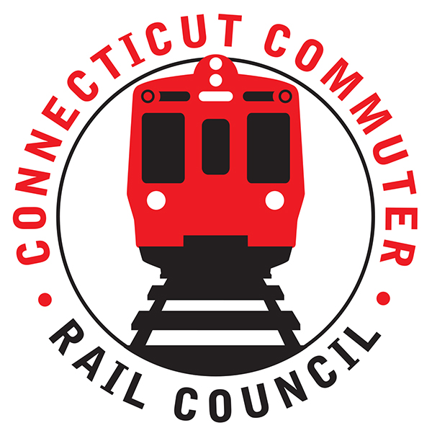

**Connecticut Commuter Rail Council**

**Minutes: Wednesday November 16, 2022 6:00 p.m.**

**via Zoom**

The following Councilmembers were in attendance: Zell Steever, Doug Hausladen, Julia McGrath, Sue Prosi, Frank Petise for Mayor Caroline Simmons, Jeffrey Maron, Kate Rozen, Jim Gildea, and Melissa Kane, Blaize Levitan, Greg Burns.

Also in attendance:

CTDOT – Rich Jankovich, Garrett Eucalitto, Benjamin Limmer (Bureau Chief of Public Transportation)

Metro North – Ben Cornelius, Mike, Michelle and Joe Lagana – transportation officers for metro north

Tom McCarthy

**Council Business**:

Chairman Gildea called the meeting called to order at 7:05pm.

The October meeting minutes were moved for approval by Zell Steever and seconded by Marcellus Edwards. The minutes approved unanimously.

**Public Comments**:

Miriam Grossman: The Hartford Union Station needs attention with regards to signage, concessions, and bathrooms. Late night offerings at various stations are lacking. Various later service so that residents can travel by train to events at night. Customer provided emails regarding customer service and other items, which were noted by the Chair.

**Commissioner Eucalitto introduces Bureau Chief of Public Transportation**

Bureau of Public Transportation Chief Benjamin Limmer had a chance to introduce himself to the council and outline their background in public transportation. Multimodal experience with large city experience in Atlanta.

**CTDOT Staffing Levels**

Commissioner Eucalitto reported on the staffing levels and good news were reported that the staffing plan is on the upswing, with over 1000 positions filled in 2022. 500 new employees and a lot of promotions and internal promotional opportunities. Vacancies are one of most crucial pieces to success as a department. New positions created thanks to legislature to staff with IIJA – including more than 30 new public transportation jobs. Rail Administrator Rich Jankovich presented on staffing of the 7 cohorts in the division of rail. A lot of turnover – of the 73 total positions in office of Rail over 50 members of the team are new. Consultant contracts support the team to support as needed, including planning and operational needs. Rich thought it was a good idea to get together offline midday to get some work plan covered. Commissioner clarified some of the details of staff reimbursement from federal projects to cover some costs, including over 250 new positions that can be 80/20 covered by federal projects that are coming through IIJA.

**Stamford Elevator Project Update**

Mike Mednick district engineer can come back and give updates on the project. The contractor is O&G doing the work, and the project is ready to go to work this year on schedule from last reported.

**Main Line Issues**

Reduction of service question from Stamford station, with regards to service levels and responding to customer count.

Waterbury line is very high passenger count. New Canaan issue was brought up and CTDOT responded that it is under full investigation at this point. Metro North is investigating with support from FRA. Discussion over authority and investigation needs in past and present.

**Hartford Line**

Tom McCarthy reported on the project near the state line on track one, which is supposed to finish up in April while working around freight lines. Peter Pan is providing bus service for past two-and-a-half weeks. Weekend service is uninterrupted with 12 trains on the weekend. Seems like the busier days are Wednesday and Saturday. Elevator issue was causing ADA issues and the team hustled to solve the accessibility issues, and thankfully the elevator is back in service and functioning as normal. Buses are on standby as a fail-safe.

**Adopt 2023 Meeting Schedule (in-person to be review)**

Quarterly in-person meeting scheduled. Moved by Doug Hausladen to approve the CCRC 2023 schedule, second by Zell Steever. Unanimous vote.

**Legislative Transportation Initiatives**

Kate Rozen presented the bills that the council is following, including main line and shoreline east bills. Waterbury Line and Shoreline East. A discussion of individual bills was led and strategies for achieving were presented. Neither of the Shoreline East bills have co-sponsors or been raised at a hearing. CTDOT agency bills do not yet have bill numbers and would come through the transportation committee. Discussion of the impact of the various bills happened and recommendations were presented for CCRC support and testimony. Jim Gildea volunteered to support on the Waterbury Line bills. Zell Steever volunteered to support on the Shoreline East bills. Blaize Levitan agreed to support on testimony or letter comments regarding agency bill on CT Public Transportation Council. Transportation Committee chairs are interested in calling all of the bills that CT Commuter Rail Council submitted.

**Adjournment**

The December meeting will be virtual. Moved by Doug Hausladen and Seconded by Zelle Steever. Meeting was adjourned by unanimous vote at 8:32PM with a note of another meeting following ours.

Respectfully submitted,

Doug Hausladen on behalf of Blaize Levitan, Secretary