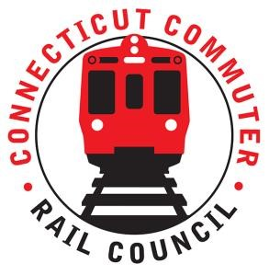

AGENDA
Wednesday January 18, 6:00 p.m. via Zoom
Conference Room
Greater Hartford Transit District
1 Union Place, Hartford, CT

1. | Welcome and Introductions | Chair | 6:00 p.m.
2. | Approval of January 2023 Minutes | Council | 6:02 p.m.
3. | Public Comment | Public | 6:04 p.m.

Council Business:
1. | Governor’s Transportation Initiatives | OOG | 6:10 p.m.
2. | Update on Hartford Line Projects and Construction | CDOT | 6:25 p.m
3. | Update on Upcoming Service impacts associated with Construction  - Hartford Line – Amtrak Projects  - New Haven Line – Stamford Elevator Escalator Project and other projects | CDOT | 6:40 p.m
4. | Main Line Issues | CDOT | 6:55 p.m.
5. | Branch Line Issues | CDOT | 7:00 p.m.
6. | Hartford Line and Shoreline Issues | CDOT | 7:10 p.m.
7. | Legislative Transportation Initiatives | Council | 7:20 p.m.
8. | Old Business / New Business | Council | 7:40 p.m.
9. | Adjourn | Council | 7:50 p.m.

Call in:
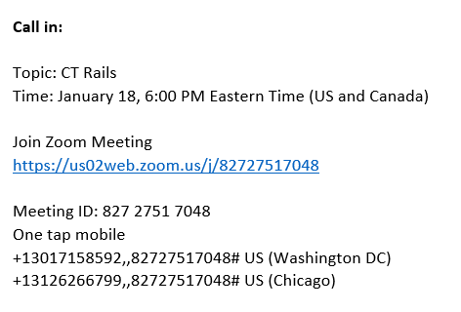

Next Meeting
February 16, 2022
Via Zoom

