

AGENDA
Wednesday February 15, 2023 7:00 p.m. via Zoom

1. | Welcome and Introductions | Chair | 7:00 p.m.
2. | Approval of January 2023 Minutes | Council | 7:02 p.m.
3. | Public Comment | Public | 7:04 p.m.

Council Business:
1. | Bureau Chief Introduction and Opening Remarks from Commissioner Eucalitto | CDOT | 7:10 p.m.
2. | CDOT Staff Levels | CDOT | 7:25 p.m.
3. | Stamford Elevator Escalator Project Update | CDOT | 7:35 p.m.
4. | Main Line Issues | CDOT | 7:45 p.m.
5. | Branches, Hartford Line and Shoreline Issues | CDOT | 7:55 p.m.
6. | Legislative Transportation Initiatives | Council | 8:05 p.m.
7. | Adopt 2023 Annual Meeting Schedule | Council | 8:15 p.m.
8. | Old Business / New Business | Council | 8:30 p.m.
3. | Adjourn | Council | 8:40 p.m.

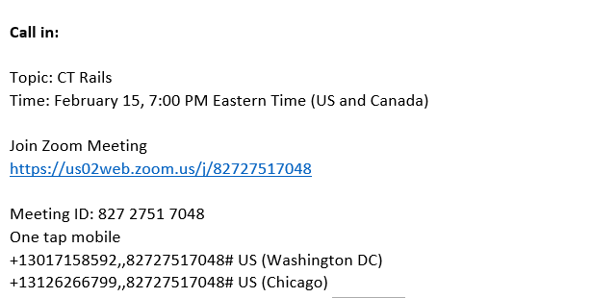

Next Meeting
March 15, 2023
T.B.D.

