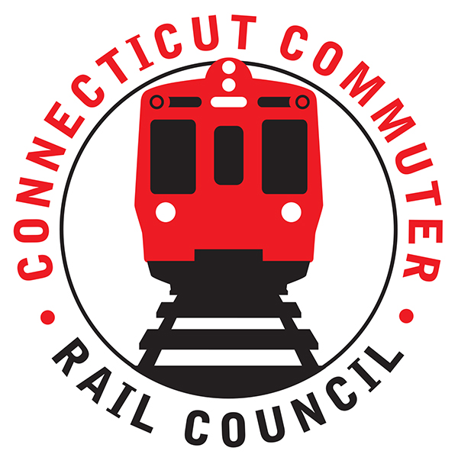

**Connecticut Commuter Rail Council**

**Minutes: Wednesday November 16, 2022 6:00 p.m.**

**via Zoom**

The following Councilmembers were in attendance: Zell Steever, Doug Hausladen, Greg Burns, Julia McGrath, Jeff Maron, Melissa Kane, and Kate Rozen. Jim Gildea, Frank Petise for Mayor Caroline Simmons.

**Council Business**:

Chairman Gildea called the meeting called to order at 7:05pm.

The October meeting minutes were moved for approval by Kate Rozen and seconded by Zell Steever. The minutes approved unanimously.

**Public Comments**:

Miriam Grossman: Would like to echo her comments from last month, with emphasis on current schedule with no good solution to last mile problem. There is no late-night service on the Hartford Line. New London station was closed at 10:30pm at night, and there’s a train at 11pm. The station should remain open when trains are still scheduled. CDOT has not provided any timeframe or intention of providing later service so that residents can travel by train to events at night. There should be a mask-only car, and they should bring the quiet-car back. Signage at NHUS in the bathrooms is down (and has been ordered), and there are a lot of unhoused persons at Union Station.

Matthew Peiser: Connecting service on the New Canaan line should have thru trains to NYC on the weekends without having to transfer trains at Stamford.

**CCRC Data Request Review**

Review of 8 open requests with Eric Bergeron as lead for rail providers. CTRail has similar requests into service providers, and they are following up on CCRC requests as well as their own requests. Ben Cornelius responded that they are hoping to have some drafts of data requests to CTDOT for review within a couple of weeks (maybe before Christmas). Ben Cornelius is in favor of the quiet car, and they will check with MTA tomorrow on where that stands.

**Hartford Based Meeting Discussion**

January is the target, and the goal is to have a hybrid meeting in the GHTD space. In-person meeting for January, and CCRC will invite the Transportation Committee Chairs, Jonny Dach and the Governor’s Office, and the rest of the transportation committee.

**Pre-Session Legislative Discussion**

Conversation was had to discuss the CCRC legislative priorities for 2023.

* Shoreline East funding to 100% of pre-covid service
* Funding for app to sync the various transit services together
* Transit User Council concept, connecting bus riders to the CCRC or a new concept
* Comments from the 5-year Capital Rail Plan may be needed to be turned into legislative ideas
* Fare free buses to continue for now at least
* Community Connectivity bonus application surrounding rail stations for sidewalks
* Look into the leveraging of State and Federal dollars, using Safe Streets and Roads for All funding as local match for the State Programs

**CT Rail Plan**

CCRC working group has drafted comments on the draft 2022-2026 CT Rail Plan. Members have seen the draft circulated via email in advance of the November meeting. The comments were displayed on the screen and discussed. Moved by Greg to approve the CCRC comments, second by Julia McGrath. Unanimous vote.

**Adjournment**

The December meeting will be virtual. Moved by Doug and Seconded by Zelle. Meeting was adjourned by unanimous vote at 6:46PM with a note of another meeting following ours.

Respectfully submitted,

Doug Hausladen on behalf of Blaize Levitan, Secretary