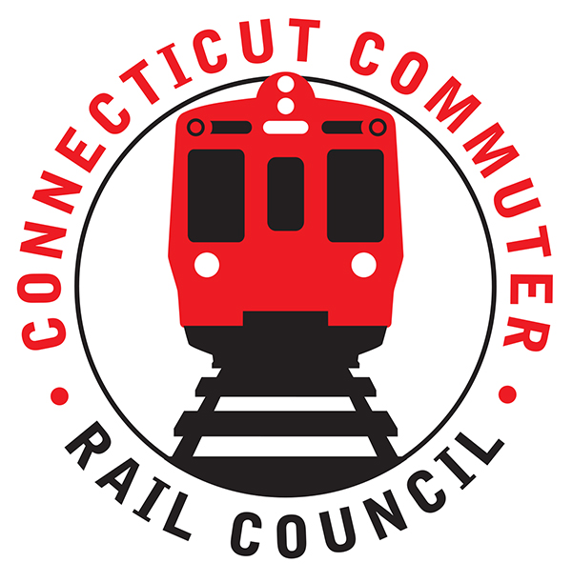

**Connecticut Commuter Rail Council**

**Minutes: Wednesday, June 15, 2022 – 7:00 PM**

**Via ZOOM**

The following Councilmembers were in attendance: Jim Gildea, Zell Steever, Sue Johnson, Doug Hauslauden, Blaize Levitan, Jessica Bremner, Julia McGrath, and Kate Rozen.

The following also attended: Ben Cornelius, MNRR; Samantha Hawkins, MNRR; Angelo Lluberes, CDOT; Eric Bergeron, CDOT; Joe Lagana, MNRR; members of the public.

**Council Business**:

Meeting called to order at 7:04pm.

Motion to approve May minutes by Zell S. Seconded by Julia M. Minutes approved.

**Public Comments**:

Miriam Grossman. Continued frustrations over poor mask compliance and no enforcement from MNR Conductors, even Conductors don’t wear masks. What happens when a customer submits a complaint to MNR? Recently did so and only receives same canned responses. Can MNR bring back a quiet car? Continued frustration with no late-night Hartford Line service and no connecting bus services lined up with SLE schedules. MNR advised that they would bring this issue to the correct Division, complaints go to a person, but they usually have generic responses ready based on the issue. Jim G asked Miriam to forward an example. MNR advised the MTA Board is against the quiet car due to overcrowding issues. Many council members expressed they share Miriam’s frustrations. CDOT advised they continued to look at the schedule issue on the Hartford Line.

Tanner Thompson of Norwalk. Would like to see transit agencies think of the rail system as regional rail, not just commuter lines. Would like to see clockface schedules, current schedule has no standardization. Every time, every hour is different and so are transfers. Need to advocate to Legislature that train transit should be included in free/reduced fare, like bus fare and gas tax cut. MNR advised clockface is very challenging.

**MNR Survey Results and Upcoming Survey:**

Samantha Hawkins of MNR presented this item. She did not have any results from the fall 2021 survey to present. Fall 2021 survey was the first combined customer satisfaction survey for the MTA, the spring 2022 survey is now live. Results must be presented to the MTA Board before they can be presented to the Council. Plan to conduct survey twice per year, email only (phone option, not advertised, for people who can’t complete online). Her team looks to amplify voice of commuters internally to MTA, identify areas for improvement. MNR will share results with the Council. CDOT had a chance to review the survey before it went out, but the Council would like to review the next one too. The Council used to review the MNR customer survey before the pandemic.

**SLE schedule adjustments:**

Eric Bergeron of CDOT presented topic. Advised they are working with Amtrak on a summer schedule adjustment, this adjustment will not be an increase in service. There are no planned service increases by CDOT at this time. CDOT is monitoring ridership, M8s rollout has been successful. There still is no plan to return the THRU Express service on SLE.

**HB 5423 Update - Expansion of Rail Service for SE CT:**

Eric Bergeron of CDOT presented topic. In February 2022, a Steering Committee was established. Data review of existing conditions almost complete. CDOT plans to solicit public involvement through June and July, also plan to reach out to major regional employers. CDOT already advising that the Legislature’s mandated timeline will be challenging to satisfy.

**WBL Final Schedule and Kickoff:**

CDOT and MNR in process of negotiating final schedule, nearly complete. Plan to start new schedule on July 11, 2022. There are public events being planned, but nothing to announce at this meeting.

**Main Line/Branch Line Issues**:

Ben Cornelius of MNR lead topic. Main Line is above 60% of pre-covid weekday ridership, weekend ridership is fully recovered. Yesterday was highest ridership day since COVID started. NHL comprises 48% of MNR’s total ridership. Tuesday’s are the heaviest travel days, followed by Wednesday. Will soon be adding more mid-day trains, almost every half hour, being coordinated with WBL. MNR: Frequency builds ridership.

**Hartford Line and Shoreline Issues**:

M8s implemented in May. Blaize Levitan asked about a return of the THRU Express service and if the schedule could be adjusted as service is still decreased and challenging for working people. Eric Bergeron said there is still no timeline for return of the express service or a planned service increase.

The Hartford Line has strongest ridership outside of the Main Line. With M8s on SLE, more equipment for the HL. Blaize Levitan asked for an update on the SLE trip planner from 8 months ago, which includes planning for MNR connections, but not HL. CDOT advised they are still looking into it.

**Old Business/New Business**

Working Group meeting next Wednesday. July meeting will focus on budget, CDOT working to confirm Garrett. The August meeting will focus on the WBL and the September meeting is the next planned in-person meeting, with focus on SLE. Council working on building up attendance and advocacy for the in-person meeting.

Meeting was adjourned at 8:10PM

Respectfully submitted,

Blaize Levitan, Interim Secretary