**AGENDA**

**Wednesday November 16, 2022 6:00 p.m. via Zoom**

|  |  |  |  |
| --- | --- | --- | --- |
| **1.** | **Welcome and Introductions** | **Chair** | **6:00 p.m.** |
| **2.** | **Approval of October Minutes** | **Council** | **6:02 p.m.** |
| **3.** | **Public Comment** | **Public** | **6:04 p.m.** |

|  |  |  |  |
| --- | --- | --- | --- |
| **Council Business:** | |  |  |
| **1.** | **CCRC Data Request Review** | **CDOT** | **6:10 p.m.** |
| **2.** | **Hartford Based Meeting Discussion** | **Council** | **6:25 p.m.** |
| **3.** | **Pre-Session Legislative Discussion** | **Council** | **6:30 p.m.** |
| **4.** | **CT Rail Plan** | **Council** | **6:50 p.m.** |
| **5.** | **Adjourn** | **Council** | **7:00 p.m.** |

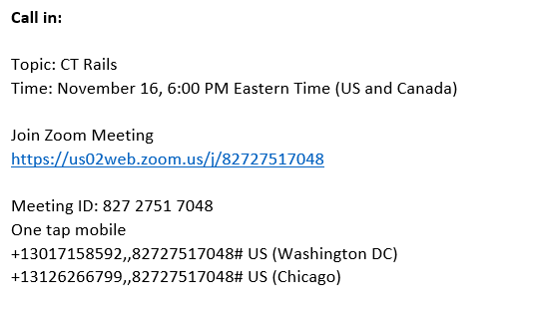

**Next Meeting**

**December 21, 2022**

**T.B.D.**