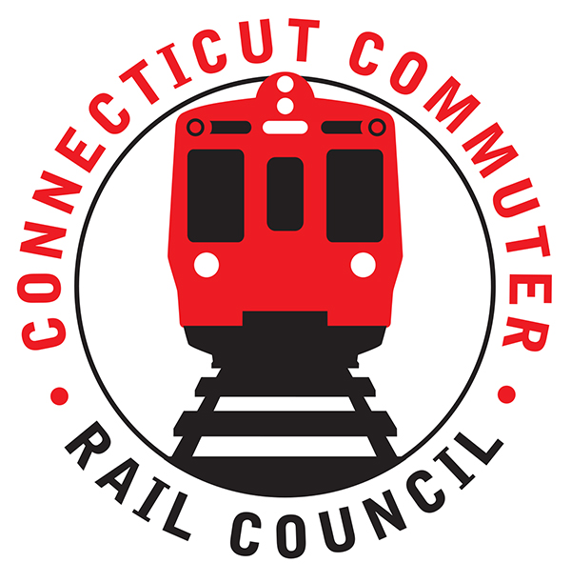

**Connecticut Commuter Rail Council**

**Minutes: Wednesday, May 18, 2022 – 7:00 PM**

**Via ZOOM**

The following Councilmembers were in attendance: Jim Gildea, Zell Steever, Sue Johnson, Doug Hauslauden, Blaize Levitan, Jeff Maron, Greg Burnes, Jessica Bemner, Melissa Kane, Julia McGrath, and Kate Rosen.

The following also attended: Ben Cornelius, MNRR; Angelo Lluberes, CDOT; Eric Bergeron, CDOT; Joe Lagana, MNRR; members of the public.

**Council Business**:

Meeting called to order at 7:05pm.

Motion to approve April minutes by Jeff M. Seconded by Sue P. Minutes approved.

**Public Comments**:

Tanner Thompson of Norwalk. Took trip to New Haven but frustrating not being able to bring bikes onto peak trains. Can MNR find a way to allow more bikes on trains? Ben Cornelius of MNR said he likes the idea, but it is very challenging, will talk with CDOT and the Council further.

Miriam Grossman. Very happy about free bus fares. There are no train options back to New Haven from Hartford after events. Can CDOT restore the 11:30pm train service? There also is not adequate bus and train service on Sundays. Upset about poor mask compliance on trains and CDOT removal of mask requirement on CT Rail. CDOT advised they are following federal policy, will look into late-night service after events as they recognize the need.

Peter Gold of Westport. Upset about poor mask compliance, MNR conductors don’t enforce or even ask. Can there be a mask-optional car? For Westport area- Wheels2You bus service solves the last-mile problem.

**CDOT Electrification Update**

Ruby Siegel of AECOM presented information for CDOT. CDOT will be conducting a feasibility study of Danbury and Waterbury lines. The plan is currently in conceptual stage, as CDOT and AECOM are finalizing scope. Plan includes looking at systemwide safety, assessing previous studies, and reviewing existing conditions. The study should take about 12 months to complete once it is started. There was a short Q&A session with Councilmembers and Ruby Siegel.

**RFP Coach Procurement:**

RFP has been posted on the State’s website. Bids will be accepted until October 31, 2022. More information can be found here:

<https://webprocure.perfect.com/wp-web-public/#/bidboard/bid/100834?customerid=51>

**Time for CT Update:**

Ruby Siegel led update. This project is off to a slow start, with no travel time reduced yet. CDOT and MNR plan to implement a pilot program this fall to reduce scheduled travel time from New Haven to Grand Central by 10 minutes. This reduction is primarily based on schedule design, not infrastructure improvements and is focused on travelers heading in and out of NYC. There was a Q&A session with CDOT. Many Councilmembers expressed interest in more intra-state express service. CDOT will keep the Council updated on progress.

**Public Bureau Chief Update:**

Rich Andreski will be leaving CDOT. Council gives him a huge thanks for his service and the vision he brought to CT Rail. Job is posted for new Bureau Chief.

**Main Line/Branch Line Issues**:

Jim Gildea asked if there could be a minor adjustment in the WBL schedule to accommodate people that get out of work at 4:00pm. Current schedule is difficult to make train and long wait until next service. Blaize Levitan commented about outstanding performance of MNR conductor on the 5:16PM train from Greenwich to New Haven.

**Hartford Line and Shoreline Issues**:

M8s being implemented this month. Blaize Levitan asked about a return of the THRU Express service. Eric Bergeron said there is still no timeline for return of the service.

**Old Business/New Business**

The June 2022 meeting will be held virtually. The August meeting will focus on the WBL and the September meeting is the next planned in-person meeting, with focus on SLE.

Meeting was adjourned at 8:24PM

Respectfully submitted,

Blaize Levitan, Interim Secretary