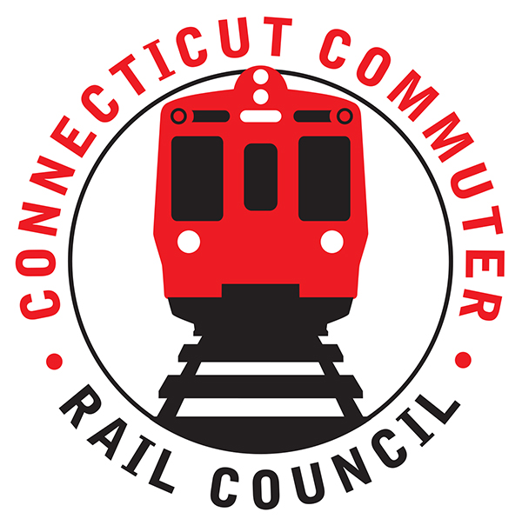

**Connecticut Commuter Rail Council**

**Wednesday, March 17, 2021 – 7:00 PM**

**Via Video Conference**

The following Council Members were in attendance by video conference: Jim Gildea, Jeff Maron, Sue Prosi, Melissa Kane, Doug Hauslauden, Ed Schroeder, Terry Borjerson, Mitch Fuchs, and Roger Cirella.

The following people also attended by video conference: Senator Will Haskell, Richard Jankovich, CDOT; Richard Andreski, CDOT; Garrett Eucalito, CDOT Deputy Commissioner; Yuri Kulijis, CDOT; Jon Foster, CDOT; Tom McCarthy, CT Rail; John Bernick, CDOT; Jim Carlson, Amtrak; Ben Cornelius, MNRR; David Melillo, MNRR; Frank Pomes, MNRR; Zell Steever, and Miriam Grossman.

**Public Comments**:

Senator Will Haskel said he was looking forward to working with the Council. Miriam Grossman said there is no enforcement of masks at GCT. Lior Trestman asked if there was something MNRR can do about the train horns in New Haven. Frank Pomes said the horn blowing is a federal mandate at railroad crossings and there is nothing MNRR can do. There is no requirement to sound the horn if there is no one on the platform. The February 2020 minutes were approved. Mitch Fuchs abstained from the vote.

**Counsel Business**:

1. Recent Ridership Trends & Upcoming Projections:

Connecticut is looking at the NY study. Ten (10) percent of riders are not coming back. Fifty-six (56%) will commute two (2) or three (3) days a week. Ridership is returning slowly. In February 2021, New Haven Line (NHL) ridership is projected to be twenty (20) percent of February 2019 and in December 2021, NHL ridership is projected to be thirty-seven (37%) of December 2019. Rich Andreski mentioned the focus now is to improve service. There will be a customer outreach in June. For Shore Line East (SLE), John Foster mentioned that SLE ridership in September 2021 is projected to be sixteen (16) percent of September 2019 and in December 2021 SLE ridership is projected to be nineteen (19) percent of December 2019. For the Hartford Line, January 2021 ridership is projected to be thirty-two (32%) percent of January 2019 and for February 2021 ridership is projected to be thirty-one (31%) percent of February 2019.

1. Governor’s Office Proposed Budget:

A portion of the sales and use tax will go into the STF in 2023. The Governor’s plan is to reduce long term debt. The plan is to expand the Waterbury Line in 2023. The budget includes a large truck tax and a tax on cannabis. Jim Gildea asked if there were any cuts. Garrett Eucalito said there were no cuts in the budget. Current rail service will continue.

1. CDOT 5 Year Capital Plan

John Bernick said that the plan is to maintain a state of good repair. The plan includes funding for improvements to the Darien railroad station, SLE public information display upgrades, Waterbury High Level Platform Design, Devon Bridge Design, New Haven Rail Yard maintenance, and the expansion of the Hartford Line. A question was asked about speed improvements in 2025. John said speed improvements will happen operationally. There will be speed improvements after the Walk project.

1. American Rescue Plan (Specific to Rail Transportation):

Connecticut has received funding but we are waiting to see how much. The funds will have to be split with neighboring states. Garrett mentioned that there will be a credit to CT for what CT owes Amtrak.

1. Main Line Issues:

Nothing to Report.

1. Branch Line, Hartford Line, Shore Line Issues:

CT House Bill 5423 was briefly discussed. HB 5423 is a bill to study the expansion of passenger train and ground transportation services in the eastern region of the state.

1. Annual Meeting Schedule:

The June 2021 meeting will focus on the Hartford Line. In person meetings will be considered this year.

Adjourned at 8:38 pm.

|  |
| --- |
|  |

Respectfully submitted,

|  |  |  |  |  |  |
| --- | --- | --- | --- | --- | --- |
| Roger J. Cirella, Secretary |  | |  | |  |
|  |  | |  | |  |
|  |  | |  | |  |
|  |  | |  | |  |
|  |  | |  | |  |
|  |  | |  | |  |
|  |  | |  | |  |
|  | |  | |  | |