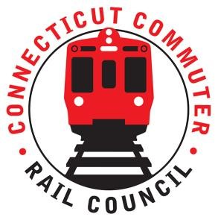

AGENDA
Wednesday September 21, 6:30 p.m. Hybrid

1. | Welcome and Introductions | Chair | 6:30 p.m.
2. | Approval of August 2022 Minutes | Council | 6:32 p.m.
3. | Public Comment | Public | 6:34 p.m.

Council Business:
1. | Past Ridership and Service | CDOT | 7:30 p.m.
2. | Current Ridership and Service | CDOT | 7:40 p.m.
3. | Recent Shoreline East Service and Work | CDOT | 7:50 p.m.
4. | Current Service Expansion Challenges | CDOT | 8:00 p.m.
5. | Future Projects | CDOT | 8:20 p.m.
 | - New London Track 6 | CDOT | 8:20 p.m.
 | - Phase Gap – Catenary Phasing Project | CDOT | 8:25 p.m.
 | - Stations Communications and Interconnectivity | CDOT | 8:35 p.m.
3. | HB 5423 - Expansion of Rail Service for SE CT | CDOT | 8:40 p.m.
 | - HB 5423 – Eastern CT Corridor Transit and Rail Feasibility Study | CDOT | 8:40 p.m.
5. | Public Comment | Public | 8:55 p.m.
6. | Adjourn | Council | 9:10 p.m.

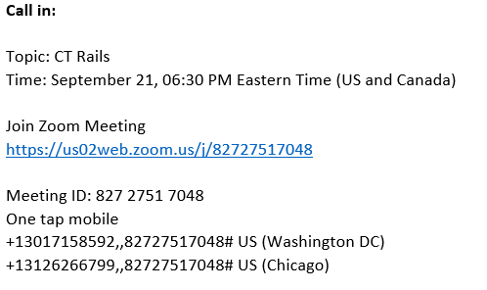

Next Meeting
October 19, 2022
T.B.D.

