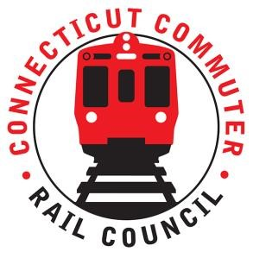

AGENDA
Wednesday June 15, 2022 7:00 p.m. via Zoom

1. | Welcome and Introductions | Chair | 7:00 p.m.
2. | Approval of May 2022 Minutes | Council | 7:02 p.m.
3. | Public Comment | Public | 7:04 p.m.

Council Business:
1. | MNR Survey Results and Upcoming Survey | CDOT | 7:10 p.m.
2. | SLE schedule adjustments | CDOT | 7:25 p.m.
3. | HB 5423 Update - Expansion of Rail Service for SE CT | CDOT | 7:35 p.m.
3. | WBL Final Schedule and Kickoff | CDOT | 7:45 p.m.
4. | Main Line / Branch line Issues | CDOT | 7:55 p.m.
5. | Hartford Line and Shoreline Issues | CDOT | 8:10 p.m.
6. | Old Business / New Business | Council | 8:25 p.m.
7. | Future Meetings | Council | 8:40 p.m.
8. | Adjourn | Council | 8:50 p.m.

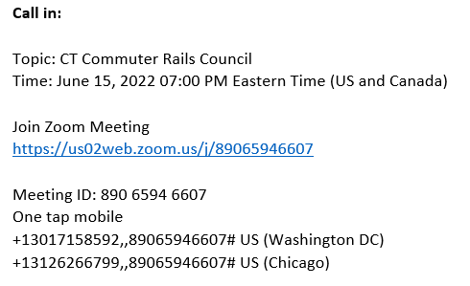

Next Meeting
July 2022
T.B.D.

