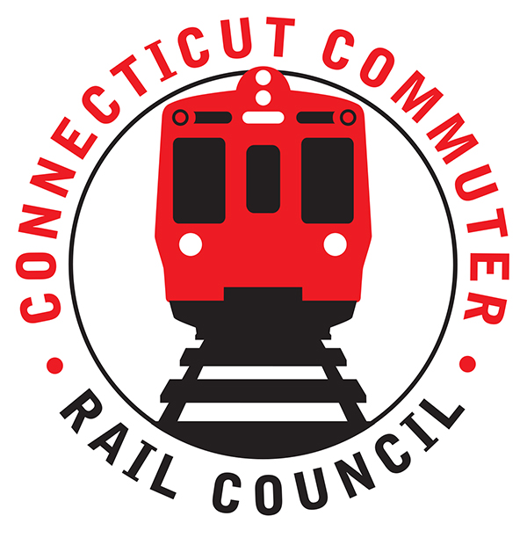

**Connecticut Commuter Rail Council**

**Minutes: Wednesday, April 20, 2022 – 6:00 PM**

**Via In-Person & Phone Conference**

The following Councilmembers were in attendance: Jim Gildea, Zell Steever, Sue Prosi, Doug Hauslauden, Blaize Levitan, Jeff Maron, and Kate Rosen.

The following also attended: Catherine Rinaldi, MNRR; Ben Cornelius, MNRR; Tom Aparo, CDOT; Eric Bergeron, CDOT; Matt Giguere, CDOT; Tom Aparo, CDOT; Michelle Salvatore, MNRR; Maureen Taylor, MNRR; Justin Vonashek, MNRR; Sean Fehey, MNRR; members of the public.

**Council Business**:

Meeting called to order at 6:02pm.

Motion to approve March minutes by Zell. Seconded by Doug. Minutes approved.

**Public Comments**:

Tanner Thompson of Norwalk. Would like to see more in-state service, service that serves the Connecticut-based commuter. The connection between the Hartford Line and MetroNorth is too long, often about 25-30 minutes. Request connection wait time be reduced and that MetroNorth and CT DOT think of rail more as regional rail instead of commuter rail service.

**MNRR President Cathy Rinaldi “State of Rail”**:

Provided rail statistics about service provision and ridership (see attached). MNRR experienced strong gains in ridership in March. Manhattan-bound weekday ridership however has remained steady at about 50% of pre-pandemic levels. New Haven Line ridership has recovered faster than other MNRR lines and Connecticut riders account for 64% of the system’s total ridership. MNRR is rethinking the future of the agency as it looks at the new post-pandemic reality.

There was a Q&A conversation focused on Connecticut-based riders, thinking of MNRR as a regional rail system instead of commuter rail system, and the low office occupancy still impacting NYC.

**CCRC Operational Metric Request**:

Members discussed the CCRC’s operational metric requests at length. The Council had officially requested rider volume by station, on-time-performance (OTP) by station or major station, and crime reports by station. Tom Aparo reviewed what CT DOT is currently able to provide for SLE and CT Rail (attached). CT DOT provided ridership volume by station but cannot provide OTP by any station at this time. CT DOT is dependent upon Amtrak for this information and advised it is not currently tracked. Tom Aparo said Amtrak may have some technology changes soon and will talk to the team at CT DOT to continue exploring how CCRC can get OTP performance data.

MetroNorth is still working on the data request. There was significant discussion regarding the goals of CCRC’s data request and MetroNorth’s capabilities to provide the data. CCRC members expressed the need to understand the experience of the Connecticut-based rail commuter, not just terminal to terminal performance. Blaize Levitan and Zell Steever also spoke about how the data can help inform schedule design and provide insight for how to improve service and experience for CT-based commuters. Jim Gildea advised that CCRC understands work involved in producing additional metrics and are comfortable with receiving it in “baby-steps.” Ben Cornelius expressed concerns about his limited staff resources. He also expressed that the MetroNorth rail system is designed for terminal-to-terminal service and there are significant challenges in producing schedules that service intermediate stations. MetroNorth committed to providing OTP by major station on the New Haven Line (New Haven, Bridgeport, Stamford).

MetroNorth will provide volume of riders by station using their current methodology, which has severe limitations. They do not have the ability to provide ridership by station, but technology or policy could change that may allow this in the future. MetroNorth will provide crime statistics per station, but Doug H pointed out that this will need to be a work in progress due to jurisdiction for local police and MTA police.

**Main Line/Branch Line Issues**:

New schedule was implemented March 27th, which added more trains and increased capacity and express service in/out of NYC. Peak fares also resumed. Outside of the impact of the Omicron wave, weekday ridership has been steady at around 50% of pre-pandemic levels. Weekend ridership has returned at nearly 80% of pre-pandemic levels. Jim Gildea asked about the lack of returning ridership plaguing the New Canaan and Danbury branch lines. Ben Cornelius speculated that the New Canaan line is very sensitive to office work trends in NYC. Weekend ridership is stronger on the line than weekday ridership. He also speculated that the Danbury line has limited service and it is faster for the NYC-bound commuter to drive into NY state and ride the Harlem line into NYC.

**Hartford Line and Shoreline Issues**:

Hartford line ridership remains consistent and has been less impacted by waves of virus than other services. Shore Line East ridership remains very low compares to pre-pandemic and the schedule is still significantly reduced. CCRC members expressed monthly concern about when service will return and remain in a “chicken and egg” situation with reduced service and reduced ridership. Blaize Levitan asked about a timeline for the return of the THRU Express service. Tom Aparo and Eric Bergeron said there is still no timeline or plan for return of the service.

**Old Business/New Business**

Doug Hauslauden suggested that the Council setup a Google Drive for conducting Council business, including setting up email addresses that we use just for Council business. He offered to explore options in advance of the next meeting.

The May 2022 meeting will be held in virtually. Jim Gildea and Eric Bergeron will work out a schedule for in-person meetings, possibly quarterly at this stage. The July meeting may be the next opportunity for in-person, focused on SLE.

Meeting was adjourned at 7:24PM

Respectfully submitted,

Blaize Levitan, Interim Secretary