

AGENDA
Wednesday March 16, 2022 p.m. via Zoom

1. | Welcome and Introductions | Chair | 7:00 p.m.
2. | Approval of February 2022 Minutes | Council | 7:02 p.m.
3. | Public Comment | Public | 7:04 p.m.

Council Business:
1. | Update on the Stamford Transportation Center | CDOT | 7:10 p.m.
2. | Rail Parking Update | CDOT | 7:25 p.m.
3. | CDOT Customer Service Plan & Action Plan | CDOT | 7:40 p.m.
4. | Legislative Update | CDOT | 7:50 p.m.
5. | Main Line / Branch line Issues | CDOT | 8:00 p.m.
6. | Hartford Line and Shoreline Issues | CDOT | 8:10 p.m.
7. | Old Business / New Business | Council | 8:40 p.m.
8. | Adjourn | Council | 8:50 p.m.

Call in:
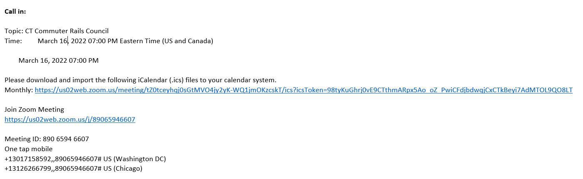

Next Meeting
April 20, 2022
T.B.D.

