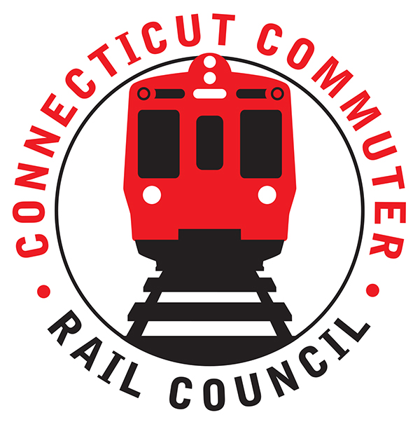

**Connecticut Commuter Rail Council**

**Wednesday, December 15, 2021 – 7:00 PM**

**Via Video Conference**

The following Council Members were in attendance by video conference: Jim Gildea, Jeff Maron, Zell Steever, Sue Prosi, Melissa Kane, Marcellus Edwards, Doug Hauslauden, Blaize Levitan, Jessica Bremner, Julia McGrath, and Roger Cirella.

The following people also attended by video conference: Rich Andreski, CDOT; Rich Jankovich, CDOT; Eric Bergeron, CDOT; Angelo Llubres, CDOT; Jon Foster, CDOT; Tom Aparo, CDOT; Mike Donnarumma, MNRR; Ben Cornelius, MNRR; Samantha Hawkins, MNRR; Robert Hale, Peter Gold, Miriam Grossman, and Terry Borjerson, members of the public.

**Public Comments**:

Miriam Grossman was concerned about the bathrooms in Grand Central Station. Miriam also mentioned her concern for the use of masks by commuters. Rich Jankovich mentioned that Union Station will be used as a vaccination site and the Bridgeport Station at a later date. Amtrak is also offering vaccination and testing. Mike Donnarumma mentioned Metronorth’s employee policy is to get tested weekly or get vaccinated.

Peter Gold received his requested information from Ben Cornelius. Peter is looking for clarification on the U ticket status. Ben will follow up.

A UCONN student asked CDOT to look into connecting the bus and the Hartford Line to the Storrs campus. At the moment, the train and the bus do not coincide. CDOT will look at the connections.

**Council Business**:

The November 2021 minutes were approved. Two (2) new members were introduced to the Council, Julia McGrath and Jessica Bremner.

**New Haven Line (Metronorth) Customer Survey**:

Samantha Hawkins discussed the survey. Emails were sent to customers and there were twenty-eight thousand (28,000) responses from Metronorth customers. The goal of the survey is to work towards a unified railroad. The survey asked questions about work behavior. For example, where are the commuters going? The data is going to be used for a twenty (20) ride ticket. The data will also be used for planning. Samantha said she can obtain New Haven Line data for the Council and will be looking for input from the Council for the next survey in the Spring.

**Ridership Trends and Service Levels**:

Tom Aparo said the New Haven Line is about fifty-two percent (52%) of pre-covid levels. Ben Cornelius is pleased that ridership isn’t decreasing with the onset of the new variant of the virus. Blaize Levitan asked what would trigger more service. Ben Cornelius said he would like to see ridership in the high fifties (50’s) before a service increase is implemented. Rich Jankovich said rail ridership may not return in the same patterns as pre-covid ridership.

**Rail Fleet Procurement Update**:

Rich Andreski said hopefully there will be an announcement next month. The equipment on the Hartford Line needs to be replaced. Ideally, CDOT would like to see the entire railroad electric. These investments take a long time. Zell Steever asked if it is possible to run battery operated cars in areas where there is no electric and Rich Andreski said CDOT is looking at battery electric rail cars.

**Main Line Issues**:

The City of New Haven signed a thirty-five (35) year lease with the New Haven Station. There are plans for new developments around Union station.

**Branch Line Issues**:

Blaize Levitan asked when the express train to Stamford from the Shore Line will resume. Rich Jankovich said it isn’t in the plan but will evaluate request.

**Hartford Line and Shoreline Issues**:

Zell Steever asked about service beyond the Shore Line. Rich Jankovich said CDOT is working with a consultant team. A report will be submitted to the legislature by January 2023. Rich Jankovich will follow up with Zell Steever.

**CT Rail Plan**:

A motion was made by Doug Hauslauden and seconded by Zell Steever to submit the Council’s working group recommendations to the legislature. The motion was carried. Jim Gildea mentioned he was very pleased with the working group’s effort.

**Annual Meeting Schedule**:

The meetings will continue by video conference. Zell Steever mentioned that in person meetings are helpful for new members but zoom capability is almost important for service providers. A hybrid meeting is planned for March 2022. The Council will revisit the schedule at the February 2021 meeting.

Adjourned at 8:50pm.

Respectfully submitted,

Roger J. Cirella

|  |
| --- |
|  |
|  |
|  |
|  |
|  |
|  |
|  |
|  |
|  |
|  |
|  |