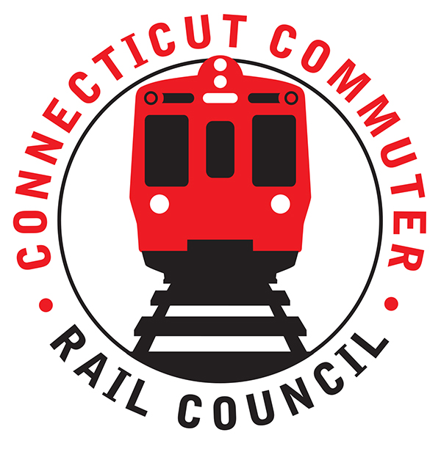

**Connecticut Commuter Rail Council**

**Wednesday, November 17, 2021 – 7:00 PM**

**Via Video Conference**

The following Council Members were in attendance by video conference: Jim Gildea, Jeff Maron, Zell Steever, Sue Prosi, Melissa Kane, Marcellus Edwards, Doug Hauslauden, Terry Borjerson, Blaize Levitan, and Roger Cirella.

The following people also attended by video conference: Joseph Guilietti, Commissioner, Garrett Eucalitto, Deputy Commissioner; Senator Roland Lemar, Senator Will Haskel, Rich Jankovich, CDOT; Eric Bergeron, CDOT; Tom Aparo, CDOT; Tom McCarthy, CT Rail; Jim Carlson, Amtrak; Jon Foster, CDOT; Yure Kuljis, CDOT; Mike Donnarumma, MNRR; Ben Cornelius, MNRR; Fred Nangle, MNRR; Kate Rattan, Rhonda Schaffer, Peter Gold, and Miriam Grossman, members of the public.

**Public Comments**:

Peter Gold asked that the Metro North survey be broken out by station. Ben Cornelius will follow up. Miriam Grossman was concerned about the signage at the Bridgeport station and also the enforcement of the mask issue. Rich Jankovich will follow up.

**Council Business**: The October 2021 minutes were approved.

**New Haven Line (Metro-North) Customer Survey**

The survey will be discussed at the December meeting.

**CT State Rail Plan**

The Commissioner said he started in rail on June 9, 1971. Thirty percent (30%) to forty percent (40%) of State employees will be leaving and as a result there will be eleven hundred (1,100) jobs will be available by June 2022 in the Department of Transportation.

FRA and FTA are participating in the Northeast Corridor Coalition. There is thirty-five (35) billion dollars available for the Northeast Corridor so Connecticut will be competing for this money.

Blaize Levitan asked the Commissioner about the plans for rail after the pandemic. The Commissioner said there are tremendous opportunities available for Connecticut. The Commissioner is concerned about personnel being assaulted. More people were working varied hours before the pandemic. Twelve hundred (1,200) employees worked remotely at CDOT. The highways have returned with a vengeance. The rail surge has returned on the weekends as opposed to the weekdays. The buses have come back faster than rail. CDOT is monitoring ridership to predict future ridership.

Zell Steever asked the Commissioner about southeastern Connecticut and transportation to Electric Boat where ninety-five percent (95%) of the employees use cars rather than public transportation. The Commissioner said intrastate commuters have returned and CDOT is working on one (1) seat rides to attract more commuters. The Commissioner said Representative Joe Courtney has been a champion on this.

Jim Gildea asked the Commissioner about the ten (10) minute reduction in travel time. The Commissioner wants more than ten (10) minutes. The Commissioner said he left Metronorth in 1998 and returned in 2014. The catenary job took too long. CDOT is looking to do better. The plan is to under promise and over deliver.

The Commissioner was asked about plans for a fare increase. The Commissioner said he had no comment at this time. He did say CDOT is looking at the vehicle mileage tax. Also, the Commissioner said CDOT is interested in clean air and would like to see more electric buses.

Jeff Maron asked the Commissioner how CDOT is going to attract commuters when there are delayed and canceled trains due to circuit issues. Commuters are hesitant to use service. The Commissioner said CDOT is cleaning trains and they are the safest way to travel. People are driving too fast on our roads.

Melissa Kane asked the Commissioner about CDOT’s plan to market rail service. The Commissioner said as commuters return and the pandemic wanes, CDOT will look at marketing in the future.

The Commissioner concluded by mentioning that our representatives should be thanked for the recent transportation funding. Five (5) years of funding can provide twenty (20) years of transportation projects. The Commissioner also mentioned that Connecticut will need a sustainable funding source.

**Ridership Trends and Service Levels**

Ben Cornelius said Metronorth is at forty-six percent (46%) of pre-covid ridership. Ridership is trending up. Trains are running at forty (40) to seventy (70) percent capacity.

**Main Line Issues:**

No discussion.

**Branch Line Issues:**

Mike Donnarumma said PTC will be cut in on the Waterbury Line this weekend and the deadline will be met.

**Hartford Line and Shoreline Issues:**

Jim Carlson said ridership is improving on the Shore Line and the M8’s are still being tested. Tom McCarthy said another round- trip train was added on the Hartford Line on November 1, 2021.

**Old Business/New Business:**

The Council will be making recommendations about the CT Rail Plan.

Doug Hauslauden made a Motion to Adjourn that was seconded by Zell Steever and the Council adjourned at 8:56pm.

|  |
| --- |
|  |
|  |
|  |
|  |
|  |
|  |
| Respectfully submitted,  Roger J. Cirella, Secretary |
|  |
|  |
|  |
|  |
|  |
|  |

|  |  |  |  |  |  |
| --- | --- | --- | --- | --- | --- |
|  |  | |  | |  |
|  |  | |  | |  |
|  |  | |  | |  |
|  |  | |  | |  |
|  |  | |  | |  |
|  |  | |  | |  |
|  | |  | |  | |