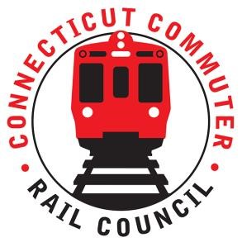

AGENDA
Wednesday December 15, 7:00 p.m. via Zoom

1. | Welcome and Introductions | Chair | 7:00 p.m.
2. | Approval of November 2021 Minutes | Council | 7:02 p.m.
3. | Public Comment | Public | 7:04 p.m.

Council Business:
1. | New Haven Line (Metro-North) Customers Survey | MNR | 7:10 p.m.
2. | Ridership Trends and Service Levels | MNR | 7:30 p.m.
3. | Rail Fleet Procurement Update | CDOT | 7:40 p.m.
3. | Main Line Issues | CDOT | 7:55 p.m.
4. | Branch Line Issues | CDOT | 8:05 p.m.
5. | Hartford Line and Shoreline Issues | CDOT | 8:15 p.m.
6. | CT Rail Plan | Council | 8:20 p.m.
7. | Annual Meeting Schedule | Council | 8:35 p.m.
7. | Old Business / New Business | Council | 8:50 p.m.
8. | Adjourn | Council | 9:00 p.m.

Call in:
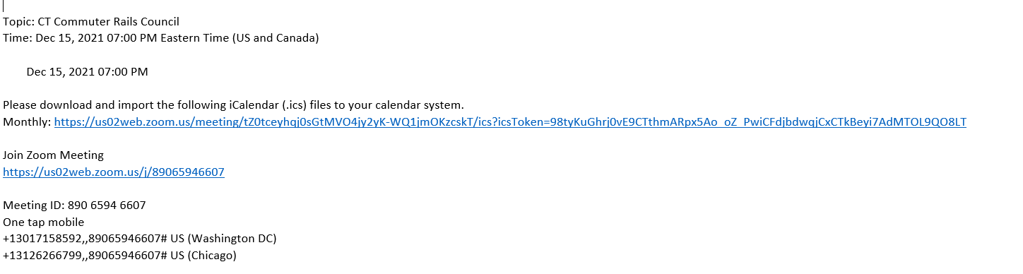

Next Meeting
January 19, 2022
To Be Determined

