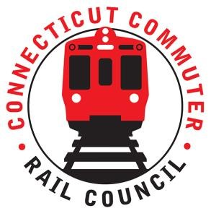

AGENDA
Wednesday November 17, 2021 7:00 p.m.
via Zoom (below)

1. | Welcome and Introductions | Chair | 7:00 p.m.
2. | Approval of October 2021 Minutes | Council | 7:02 p.m.
3. | Public Comment | Public | 7:04 p.m.

Council Business:
1. | Commissioner Giulietti (State of Rail) | CDOT | 7:10 p.m.
2. | Main Line Issues | CDOT | 8:10 p.m.
3. | Branch Line Issues | CDOT | 8:20 p.m.
4. | Hartford Line and Shoreline Issues | CDOT | 8:30 p.m.
5. | CT State Rail Plan | Council | 8:40 p.m.
6. | Old Business / New Business | Council | 9:00 p.m.
7. | Adjourn | Council | 9:05 p.m.

Call in:
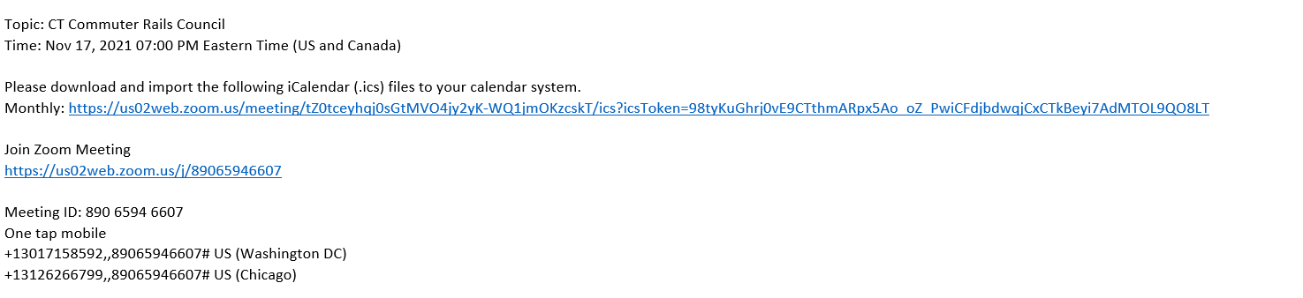

Next Meeting
December 15, 2021
To Be Determined

