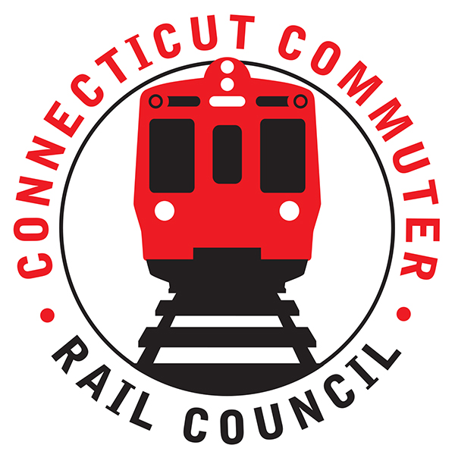

**Connecticut Commuter Rail Council**

**Wednesday, September 15, 2021 – 7:00 PM**

**Via Video Conference**

The following Council Members were in attendance by video conference: Jim Gildea, Sue Prosi, Melissa Kane, Doug Hauslauden, Blaize Levitan, Ashlee Fox and Terry Borjerson.

The following people also attended by video conference: Yuri Kulijis, CDOT; Rich Jankovich, CDOT; Tom McCarthy, CT Rail; Jim Carlson, Amtrak; Jon Foster, CDOT; John Bernick, CDOT; Sean Fahey, MNRR; Tom Aparo, CDOT; Michael Donnarumma, MNRR; Ben Cornelius, MNRR.

**Public Comments**:

There were no public comments.

**Council Business**:

The June 2021 minutes were approved. A motion was made by Terry Borjerson and seconded by Doug Hauslauden

1. **New Haven Line (Metro-North) Customers Survey:**

Rich Jankovich indicate that CDOT would be prepared to discuss this topic at our next CCRC meeting

1. **August Schedule Impact and Customer Feedback**

Metro North discussed the concept of offering more trains versus the realistic viewpoint that ridership sis still significantly down and that operationally, they are hard pressed to offer more service until ridership increases.

1. **Stamford Transportation Center (STC) Master Plan**

CDOT gave an update on the Stamford Transportation Master Plan and indicated that they would share the presentation.

1. **Ridership Trends and Service Levels**

CDOT indicated that last night’s CCRC meeting, Metro North and CDOT indicated that the August schedule change took the schedule up to 82% of the pre-Covid service levels. They said that a schedule change would not come again until spring 2022, “at best”

1. **Time for CT Update:**

CDOT indicated that are moving forward with their Time for CT Update. They are preparing a communication and website to communicate out project updates.

1. **House Bill 5423 - Expansion of Rail Service for SE CT:**

CDOT indicated that they were doing the pre-work necessary but its still early to have started and they were aware of the time frame mentioned in the bill and would meet that timing.

1. **Main Line Issues**:

Mainline issues discussed above

1. **Branch Line Issues**:

Nothing to report.

1. **Hartford Line and Shoreline Issues**:

M8’s are still being tested on SLE.

Adjourned at 8:37 pm.

|  |
| --- |
|  |

Respectfully submitted,

|  |  |  |  |  |  |
| --- | --- | --- | --- | --- | --- |
| Jim Gildea |  | |  | |  |
|  |  | |  | |  |
|  |  | |  | |  |
|  |  | |  | |  |
|  |  | |  | |  |
|  |  | |  | |  |
|  |  | |  | |  |
|  | |  | |  | |