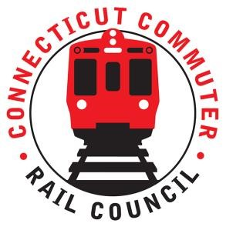

AGENDA
Wednesday September 15, 2021 7:00 p.m. via Zoom

1. | Welcome and Introductions | Chair | 7:00 p.m.
2. | Approval of July 2021 Minutes | Council | 7:02 p.m.
3. | Public Comment | Public | 7:04 p.m.

Council Business:
1. | New Haven Line (Metro-North) Customers Survey | MNR | 7:10 p.m.
2. | August Schedule Impact and Customer Feedback | CDOT | 7:20 p.m.
3. | Stamford Transportation Center (STC) Master Plan | CDOT | 7:35 p.m.
4. | Ridership Trends and Service Levels | CDOT | 7:50 p.m.
5. | Time for CT Update | CDOT | 8:00 p.m.
6. | House Bill 5423 - Expansion of Rail Service for SE CT | CDOT | 8:10 p.m.
7. | Main Line Issues | CDOT | 8:20 p.m.
8. | Branch Line Issues | CDOT | 8:30 p.m.
9. | Hartford Line and Shoreline Issues | CDOT | 8:40 p.m.
10. | Old Business / New Business | Council | 8:50 p.m.
11. | Adjourn | Council | 9:00 p.m.

Call in:
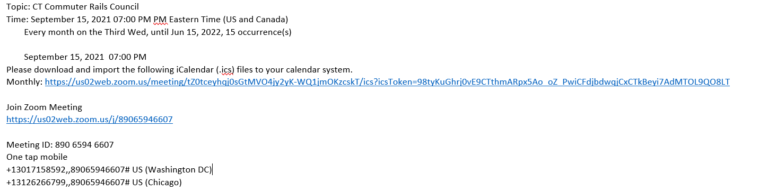

Next Meeting
October 20, 2021
To Be Determined

