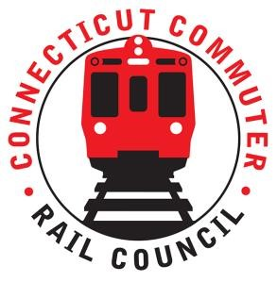

AGENDA
Wednesday August 18, 2021 &:00 p.m. via Zoom

1. | Welcome and Introductions | Chair | 7:00 p.m.
2. | Approval of July 2021 Minutes | Council | 7:02 p.m.
3. | Public Comment | Public | 7:04 p.m.

Council Business:
1. | WBL Passing siding and Branch PTC Update | CDOT | 7:10 p.m.
2. | WBL Expanded Service Update | CDOT | 7:20 p.m.
3. | RAISE Grant Derby Station Update | CDOT | 7:35 p.m.
4. | Waterbury Waiting Area Update | CDOT | 7:50 p.m.
5. | Stamford Transportation Advocacy Team | CDOT | 8:00 p.m.
6. | Federal Infrastructure Bill and Impact to CT | CDOT | 8:10 p.m.
7. | Main Line Issues | CDOT | 8:25 p.m.
8. | Branch Line Issues | CDOT | 8:35 p.m.
9. | Hartford Line and Shoreline Issues | CDOT | 8:45 p.m.
10. | Adjourn | Council | 8:55 p.m.

Call in:
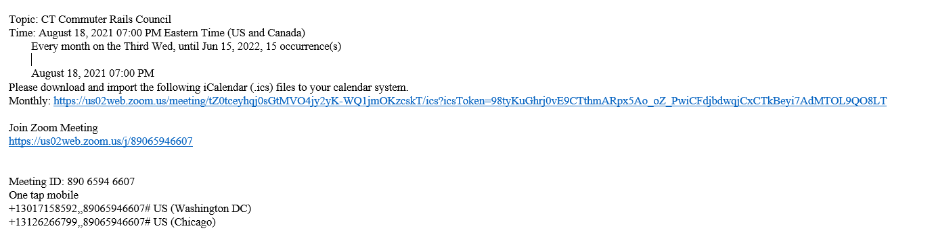

Next Meeting
September 15, 2021
To Be Determined

