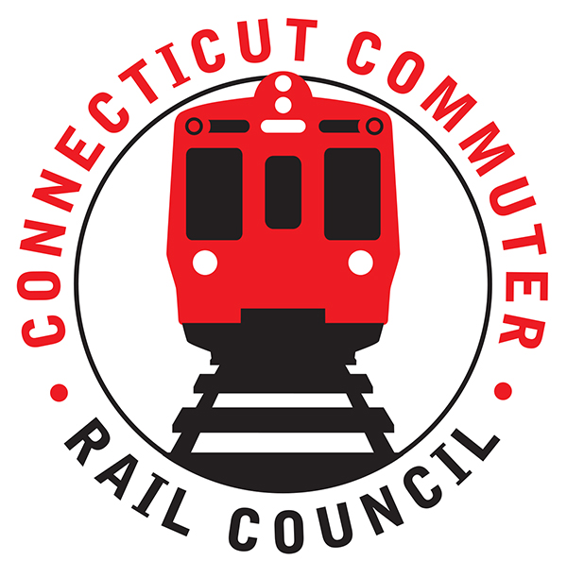

**Connecticut Commuter Rail Council**

**Wednesday, August 18, 2021 – 7:00 PM**

**Via Video Conference**

The following Council Members were in attendance by video conference: Jim Gildea, Sue Prosi, Melissa Kane, Doug Hauslauden, Blaize Levitan, Ashlee Fox, Terry Borjerson, and Roger Cirella.

The following people also attended by video conference: Representative Kara Rochelle, Carlo Leone, CDOT; Garrett Eucalitto, CDOT Deputy Commissioner; Yuri Kulijis, CDOT; Rich Jankovich, CDOT; Tom McCarthy, CT Rail; Jim Carlson, Amtrak; Jon Foster, CDOT; John Bernick, CDOT; Sean Fahey, MNRR; Tom Aparo, CDOT; Michael Donnarumma, MNRR; Ben Cornelius, MNRR; and Miriam Grossman.

**Public Comments**:

Miriam Grossman mentioned there was a problem with the toilets at Union station. Miriam also mentioned the mask issue in Grand Central Station and the gap in service on SLE. Rich Jankovich said the installation of the toilets was approved by Greater Hartford transit. As for the mask issue, CDOT is providing masks to commuters. Rich personally brought 2,000 masks to Union Station. Rich asked the council to post something on our website encouraging commuters to wear masks. Rich said the CT budget determines the level of service on SLE. SLE is currently at 60% of pre-covid ridership.

**Council Business**:

The July 2021 minutes were approved. Sue Prosi abstained. Also, Sue Prosi noted that the July 2021 minutes should be changed to reflect speed improvement rather than speed reduction. The July 2021 minutes were then approved with that change.

1. **WBL Passing Siding and Branch PTC Update:**

John Bernick said that work is progressing on the Waterbury Line. Full PTC is scheduled by July 1, 2022. MTA is targeting this November. The tie work is wrapping up. The PTC component will function as the main line operates. PTC will allow more than one train to operate at one time. John mentioned that these improvements will be a big improvement in service. There will be functioning sidings and switches now.

1. **WBL Expanded Service Update**:

John Foster said seven (7) trains will be added in July, 2022. There will be a total of twenty-two (22) trains on the Waterbury Line. Hourly service is planned at rush hour. Rich Jankovich said the infrastructure will be completed this Fall. John Bernick said the busing is scheduled to end on September 19th.

1. **Raise Grant Derby Station Update**:

John Bernick said the plan was already submitted. Station improvements include replacing the platform. The new station platform will be ADA compliant. The station will be a true transit hub. That station will also include EV charging for buses. The decision on the application should occur in two (2) to five (5) months. CDOT has been successful obtaining federal grants on the rail side. Jim Gildea asked if any expanded service is planned this Fall. Rich Jankovich said no.

1. **Waterbury Waiting Area Update:**

CDOT is working with the City of Waterbury. John Bernick said federal money is coming but the allocation has yet to be worked out.

1. **Stamford Transportation Advocacy Team:**

Carlo Leone discussed the plan for a transportation advocacy team. The plan calls for a small team of eleven (11) members. The first meeting is scheduled for September 15, 2021. Team members include representatives from People’s Bank, Charter Spectrum, UCONN Stamford, Shop Rite, City of Stamford, and CDOT. The goal of the advisory team is to promote outreach.

1. **Federal Infrastructure Bill and Impact to Connecticut:**

The bill would provide 5.3 billion dollars over five (5) years. There are also other federal grants that CT could pursue. There is a lot of money available for EV charging.

Jim thanked John Bernick for all his service and expertise that he had provided to the CCRC over the years. John Bernick will be retiring from CDOT. John began working for CDOT in 1993.

1. **Main Line Issues**:

Blaize Levitan asked how the railroad determines on time performance. Ben Cornelius said on time performance is determined at the train’s final destination. So the train can recover time along the route.

On August 29th, eight-two percent (82%) of pre-covid level service will be restored. The next schedule change is planned for the Spring.

1. **Branch Line Issues**:

Nothing to report.

1. **Hartford Line and Shoreline Issues**:

M8’s are still being tested on SLE. Sixty percent (60%) of pre-covid level service has been restored.

Weekend ridership is returning on the Hartford Line.

Adjourned at 8:37 pm.

|  |
| --- |
|  |

Respectfully submitted,

|  |  |  |  |  |  |
| --- | --- | --- | --- | --- | --- |
| Roger J. Cirella, Secretary |  | |  | |  |
|  |  | |  | |  |
|  |  | |  | |  |
|  |  | |  | |  |
|  |  | |  | |  |
|  |  | |  | |  |
|  |  | |  | |  |
|  | |  | |  | |