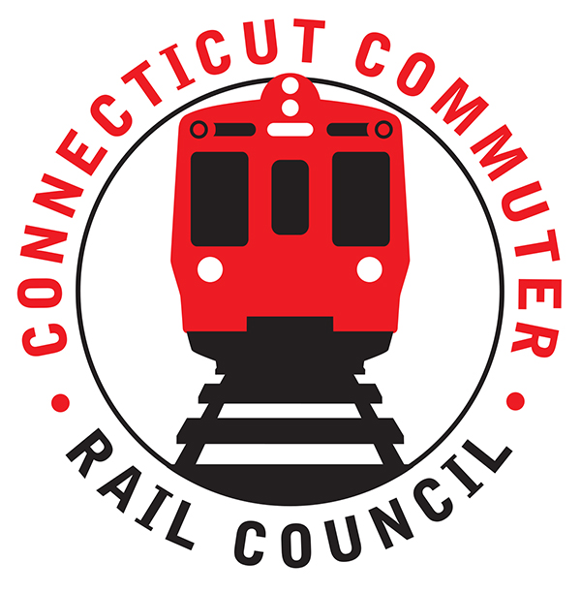

**Connecticut Commuter Rail Council**

**Wednesday, June 16, 2021 – 7:00 PM**

**Via Video Conference**

The following Council Members were in attendance by video conference: Jeff Maron, Sue Prosi, Melissa Kane, Doug Hauslauden, Mitch Fuchs, Blaize Levitan, Ashlee Fox, Ed Schroeder, Terry Borjerson, and Roger Cirella.

The following people also attended by video conference: Yuri Kulijis, CDOT; Rich Jankovich, CDOT; Jon Foster, CDOT; Tom McCarthy, CT Rail; Michael Donnarumma, MNRR; Ben Cornelius, MNRR; Robert Hale, Tanner Thompson, David Rivera, Kate Rattan, Zell Steever, and Miriam Grossman.

**Public Comments**:

Tanner Thompson, a commuter is a member of the bike walk commission. He would like to see more service. Rich Jankovich said CDOT continues to watch ridership. Covid devastated service and there are budget concerns. Jeff Maron mentioned capacity concerns including bags on seats. David Rivera, a commuter mentioned that weekend trains are very crowded. David would like to see more service. Rich Jankovich asked David if he participated in the hearings last month and that he should stay in contact with the CCRC. Miriam Grossman, a commuter appreciates the recent expanded service but is concerned about mask enforcement. Rich Jankovich will check on the status of mask enforcement. Miriam does use MTA customer service and twitter. Kate Rattan, a commuter would like to see more service. Kate would also like to see a Niantic station. Rich Jankovich said he hopes to make an announcement soon about expanded service. David Rivera mentioned a gate issue that prevented commuters from getting on the train at State Street station. Rich Jankovich apologized and said changes are coming to this station.

**Council Business**:

The May 2021 minutes were approved.

**East Side Access Service Update**:

Mike Donnarumma said work continues and it will be three (3) to four (4) years for access to Penn station. Jeff Maron requested a visit by the Council to review the progress of the project. A date will be determined.

**Returning Ridership and Future Service Plans:**

Ben Cornelius said the Waterbury Line has retained most of the ridership. It has fared the best compared to the other branches. The New Haven Line is at approximately thirty-three percent (33%) of pre-covid ridership. Four (4) round trip trains were recently added. Also, three (3) roundtrip trains were added on Saturday and two (2) roundtrip trains on Sunday. The mask issue will be difficult to enforce. Terry Borjerson asked about future service on the Waterbury Line. Ben said the plan calls for seven (7) more trains in July 2022.

**SLE Cross Honoring Tickets:**

Rich Jankovich said Amtrak is lifting capacity and evaluating service. Amtrak will get back to CDOT about cross honoring tickets.

**Main Line Issues**:

Nothing to report at this time.

**Branch Line Issues**:

Nothing to report at this time.

**SLE And HL Issues**:

Terry Borjerson mentioned that he was excited about the growth of the Hartford Line. Also, Rich Jankovich mentioned that HB 5423 (Eastern CT Rail Service Expansion) passed and is fully funded by appropriations. Freight money also came through. Rich said he would keep the Council posted on these developments.

Adjourned at 8:03pm.

|  |
| --- |
|  |

Respectfully submitted,

|  |  |  |  |  |  |
| --- | --- | --- | --- | --- | --- |
| Roger J. Cirella, Secretary |  | |  | |  |
|  |  | |  | |  |
|  |  | |  | |  |
|  |  | |  | |  |
|  |  | |  | |  |
|  |  | |  | |  |
|  |  | |  | |  |
|  | |  | |  | |