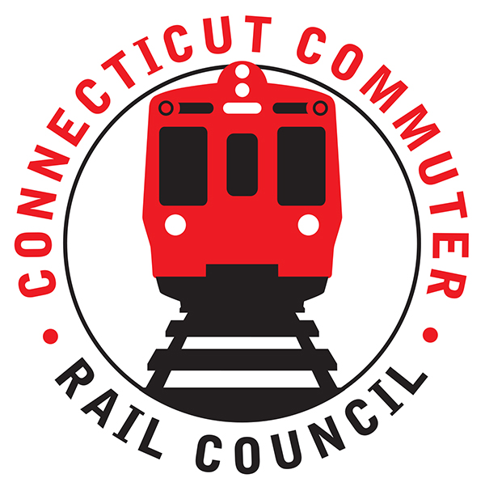

**Connecticut Commuter Rail Council**

**Wednesday, May 19, 2021 – 7:00 PM**

**Via Video Conference**

The following Council Members were in attendance by video conference: Jim Gildea, Jeff Maron, Sue Prosi, Melissa Kane, Doug Hauslauden, Ed Schroeder, Terry Borjerson, and Roger Cirella.

The following people also attended by video conference: Yuri Kulijis, CDOT; Jon Foster, CDOT; Jim Carlson, Amtrak; David Melillo, MNRR; Michael Donnarumma, MNRR; Sean Fahey, MNRR; Zell Steever, Blaize Levitan, Ashlee Fox, and Miriam Grossman.

**Public Comments**:

Miriam Grossman, a commuter said the train scheduling and masking by commuters needs to be improved.

**Council Business**:

Ashlee Fox introduced herself to the Council. She is a recently appointed member of the Council who lives in Fairfield, CT and owns her own marketing company. The April 2020 minutes were approved. Jeff Maron noted that the Council is still waiting on a CDOT presentation by Marci Peterson of CDOT.

**Update on Feasibility Study Fast Track DBL to GCT**:

Yuri Kulijis will be involved with this two (2) year study. The track from Beacon, NY to Danbury is currently inactive.

**Future Danbury branch improvements:**

A new station is planned at Merritt 7. Security cameras will be added to stations. Track work is ongoing. Construction has already begun and improvements are scheduled to be completed in September 2022.

Jim asked if rail cars can be repurposed. Yuri said mixing fleets can be problematic. Jim mentioned he would like to see spare rail cars on the Waterbury and Danbury Line.

**Service and Fare Equity Analysis:**

The New Haven Line service is down 49.2%, the Danbury Line is down 42.9%, and SLE is down 55.6%.

The Danbury Line had no disparate impacts. COVID 19 eliminated peak fare.

**Update on CGA Rail Bills out of Committee**:

HB 5423 (Eastern CT Rail Service Expansion) has gone to appropriations committee.

SB 576 (Waterbury Line Expansion) has also gone to appropriations committee.

**Main Line Issues**:

A question was asked about the Operations Report and whether the numbers could be made relevant. It was suggested that the operations report include 2019 numbers so we can compare to normal.

**Branch Line Issues**:

Mike Donnarumma said the Waterbury Line will be shut down for three (3) months. Peter Pan will be the bus service provider.

Adjourned at 8:12pm.

|  |
| --- |
|  |

Respectfully submitted,

|  |  |  |  |  |  |
| --- | --- | --- | --- | --- | --- |
| Roger J. Cirella, Secretary |  | |  | |  |
|  |  | |  | |  |
|  |  | |  | |  |
|  |  | |  | |  |
|  |  | |  | |  |
|  |  | |  | |  |
|  |  | |  | |  |
|  | |  | |  | |