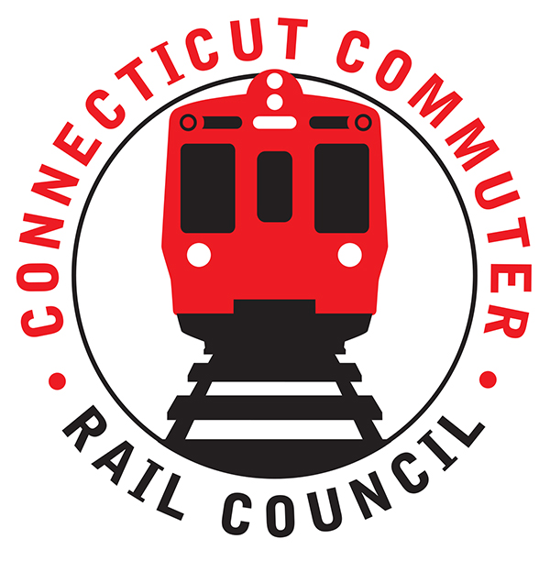

**AGENDA**

**Wednesday, June 16, 2021 – 7:00 PM**

**Via Zoom Video Conference (info below)**

|  |  |  |  |
| --- | --- | --- | --- |
| **1.** | **Welcome, introductions** | **Chair** | **7:00 p.m.** |
| **2.** | **Approval of May minutes** | **Council** | **7:02 p.m.** |
| **3.** | **Public Comments – 3 minutes each** | **Public** | **7:04 p.m.** |

**COUNCIL BUSINESS:**

|  |  |  |  |
| --- | --- | --- | --- |
| **1.** | **East side access project update** | **MNRR** | **7:15 p.m.** |
| **2.** | **Returning Ridership and Future Service Plans** | **MNRR** | **7:25 p.m.** |
|  |  |  |  |
| **3.** | **SLE Cross Honoring Tickets** | **CDOT** | **7:45 p.m.** |
|  |  |  |  |
| **4.** | **Main Line Issues** | **CDOT** | **8:05 p.m.** |
|  |  |  |  |
| **5.** | **Branch Line issues** | **CDOT** | **8:15 p.m.** |
|  |  |  |  |
| **6.** | **SLE and HL Issues** | **CDOT** | **8:25 p.m.** |
|  |  |  |  |
| **7.** | **Adjourn** | **Council** | **8:35 p.m.** |

**Call in:**

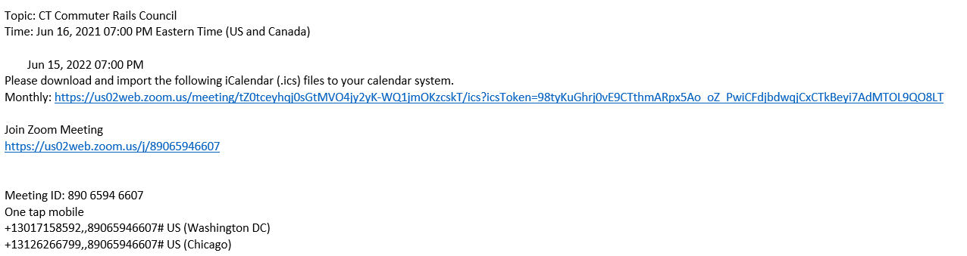

**NEXT MEETING: July 21, 2021**

**Site: TBD**