

**AGENDA**

**Wednesday, April 21, 2021 – 7:00 PM**

**Via Zoom Video Conference (info below)**

|  |  |  |  |
| --- | --- | --- | --- |
| **1.** | **Welcome, introductions** | **Chair** | **7:00 p.m.** |
| **2.** | **Approval of March minutes** | **Council** | **7:02 p.m.** |
| **3.** | **Public Comments – 3 minutes each** | **Public** | **7:04 p.m.** |

**COUNCIL BUSINESS:**

|  |  |  |  |
| --- | --- | --- | --- |
| **1.** | **SLE service update and future plans** | **CDOT** | **7:15 p.m.** |
| **2.** | **SLE Fleet Procurement Plan** | **CDOT** | **7:25 p.m.** |
|  |  |  |  |
| **3.** | **SLE M8 Testing** | **CDOT** | **7:45 p.m.** |
|  |  |  |  |
| **4.** | **SLE Station Update (Clinton / Madison)** | **CDOT** | **7:55 p.m.** |
|  |  |  |  |
| **5.** | **House Bill 5423 Update** | **Council** | **8:10 p.m.** |
|  |  |  |  |
| **6.** | **Main Line Issues** | **CDOT** | **8:20 p.m.** |
|  |  |  |  |
| **7.** | **Branch Line issues** | **CDOT** | **8:30 p.m.** |
|  |  |  |  |
| **8.** | **Adjourn** | **Council** | **8:40 p.m.** |

**Call in:**

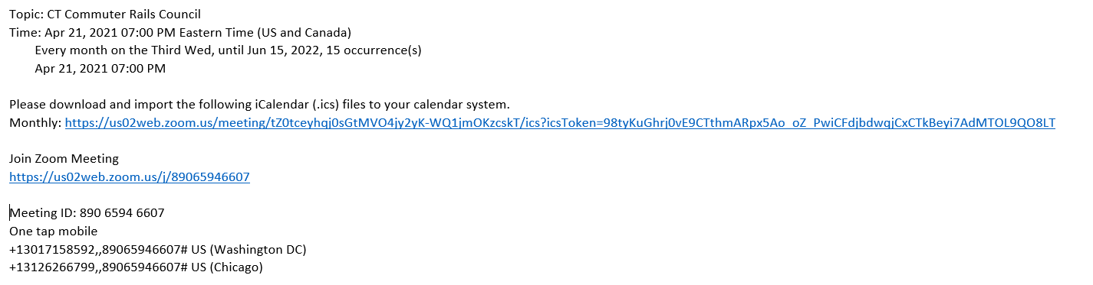

**NEXT MEETING: May 19, 2021**

**Site: TBD**