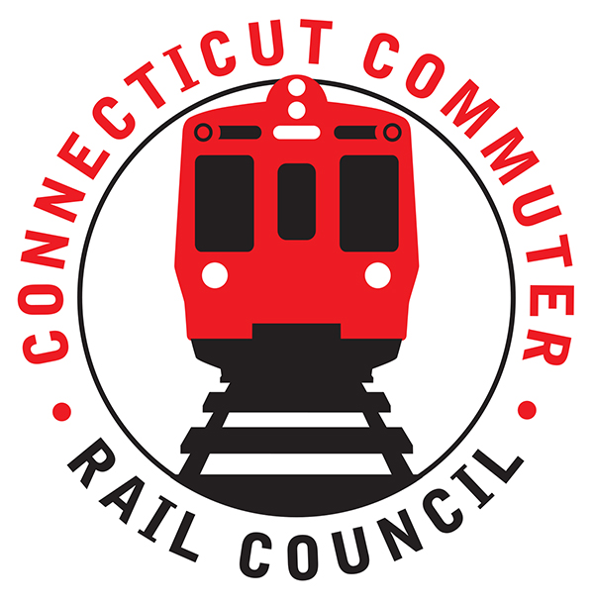

**Connecticut Commuter Rail Council**

**Wednesday, February 17, 2021 – 7:00 PM**

**Via Video Conference**

The following Council Members were in attendance by video conference: Jim Gildea, Jeff Maron, Sue Prosi, Melissa Kane, Doug Hauslauden, Terry Borjerson, and Roger Cirella.

The following people also attended by video conference: Richard Jankovich, CDOT; Richard Andreski, CDOT; Garrett Eucalito, CDOT Deputy Commissioner; Tom McCarthy, CT Rail; John Kesich, MNRR; David Kubacek, MNRR; Zell Steever, and Miriam Grossman.

Jim Gildea started the meeting by thanking John Kesich for attending the CCRC meetings. John is retiring from MNRR next month. John did an excellent job explaining very complex rail issues in a manner that the average commuter could understand. John thanked the Council and said that he enjoyed the meetings.

The January 2021 minutes were approved. Terry Borjerson made the motion seconded by Melissa Kane.

**Public Comments**:

Miriam Grossman brought up the mask issue on trains. She is concerned about mask enforcement by commuters and the possibility of adding additional service. Zell Steever brought up House Bill 5423 that directs a feasibility study for the Norwich Branch Line. Zell said Electric Boat will be hiring an additional twelve thousand (12,000) employees. Rail service would alleviate traffic. Jim Gildea said he would submit testimony.

**Counsel Business**:

1. **M8 PTC Software Performance Issues**:

John Kesich said the M-8’s went into service in February 2011. The M-8’s come with base hardware for PTC. The MDBF (Mean Distance Between Failure) was five hundred thousand (500,000) miles in 2020. The M-8’s have done very well. John Kesich described the service issue as a PTC anomaly. Kawasaki is releasing new software. Dave Kubacek said there will be three (3) software revisions this year. The revisions are scheduled for this Spring, Summer, and Fall. Metronorth is taking this software issue very seriously.

1. **Main Line and Branch Service Issues**:

The MDBF set a record in 2020. The Branch Line also performed well due to CDOT’s contributions. The BL-20’s are currently being overhauled. The mask policy has not been an issue. Conductors are doing a good job.

1. **Hartford Line & Shoreline Issues**:

Tom McCarthy said there are slight improvements in ridership. Weekend ridership is also improving.

1. **CT Rides Return To Work Survey Results:**

CT Rides is a program of DOT. The program informs commuters of their travel options. The program goal is to lower greenhouse gas emissions. This survey was completed to see how people are traveling and what their plans will be after the pandemic. Sixteen hundred (1600) people from Hartford and New Haven County were polled. Twenty-three percent (23%) of the survey respondents want to return to work. This past July, people began returning to work but by car. Many of the respondents worked in insurance, IT, and education. Many of the respondents had the option of working remotely. Bus riders may not have the option of taking a car to work. The top commuting concerns were whether areas on buses and trains were clean and sanitized. Train commuters want to see more service. The mask requirement is a concern to returning to mass transit. The consensus was that commuters do not want to return to work and those that do will return to their cars. Jim Gildea asked what the employers’ plans were. The employers will make that decision. Sue Prosi asked what the forecasts look like after the pandemic. Rich Andreski mentioned that CDOT was concerned about the capacity issue before the pandemic but now CDOT has breathing room. Rich Jankovich said CDOT is tracking ridership and they are trying to predict what it look like after the pandemic. Rich Andreski said another survey will be completed this Spring. Doug Hauslauden asked if the survey questioned whether employers offered a pre-tax commuter benefit for their employees. That question was not included in this survey.

1. **CDOT 5 Year Capital Plan:**

No discussion.

1. **Annual Meeting Schedule:**

The 09/22/21 meeting location will move. The meetings will all begin at 7pm.

1. **Annual Report:**

The report will be finished soon.

Adjourned at 8:25pm.

|  |
| --- |
|  |

Respectfully submitted,

|  |  |  |  |  |  |
| --- | --- | --- | --- | --- | --- |
| Roger J. Cirella, Secretary |  | |  | |  |
|  |  | |  | |  |
|  |  | |  | |  |
|  |  | |  | |  |
|  |  | |  | |  |
|  |  | |  | |  |
|  |  | |  | |  |
|  | |  | |  | |