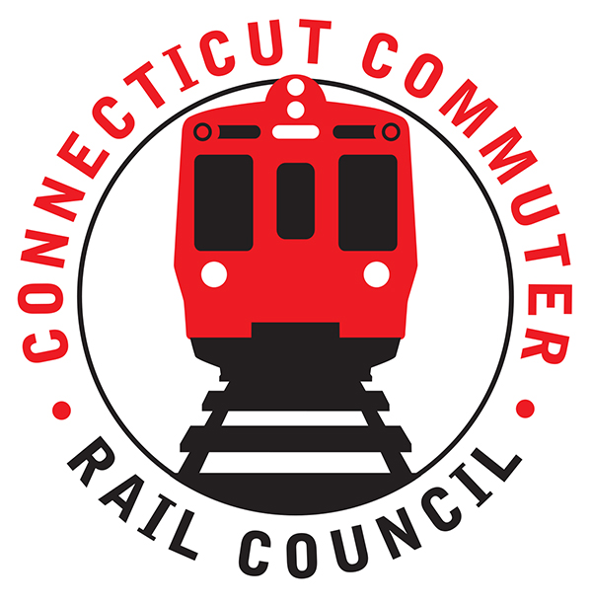

**AGENDA**

**Wednesday, March 17, 2021 – 7:00 PM**

**Via Zoom Video Conference (info below)**

|  |  |  |  |
| --- | --- | --- | --- |
| **1.** | **Welcome, introductions** | **Chair** | **7:00 p.m.** |
| **2.** | **Approval of February minutes** | **Council** | **7:02 p.m.** |
| **3.** | **Public Comments – 3 minutes each** | **Public** | **7:04 p.m.** |

**COUNCIL BUSINESS:**

|  |  |  |  |
| --- | --- | --- | --- |
| **1.** | **Recent Ridership Trends & Upcoming projections** | **CDOT** | **7:10 p.m.** |
| **2.** | **Governor’s Office Proposed Budget** | **CDOT** | **7:20 p.m.** |
|  |  |  |  |
| **3.** | **CDOT 5 Year Capital Plan** | **CDOT** | **7:40 p.m.** |
|  |  |  |  |
| **4.** | **American Rescue Plan Act (specific to rail transportation)** | **CDOT** | **8:00 p.m.** |
|  |  |  |  |
| **5.** | **Main Line Issues** | **CDOT** | **8:10 p.m.** |
|  |  |  |  |
| **6.** | **Branch Line, Hartford Line, Shoreline Issues** | **CDOT** | **8:20 p.m.** |
|  |  |  |  |
| **7.** | **Annual Meeting Schedule** | **Council** | **8:30 p.m.** |
| **8.** | **Adjourn** | **Council** | **8:35 p.m.** |

**NEXT MEETING: April 21, 2021**

**To Be Determined**

