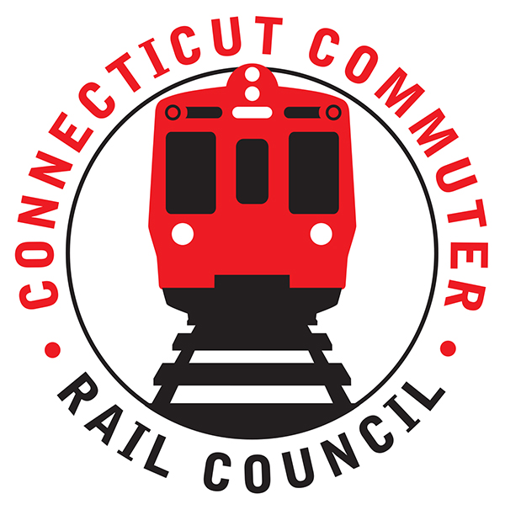

**Connecticut Commuter Rail Council**

**Wednesday, January 20, 2021 – 7:00 PM**

**Via Video Conference**

The following Council Members were in attendance by video conference: Jim Gildea, Jeff Maron, Sue Prosi, Melissa Kane, Doug Hauslauden, Peter Garneau, E.C. Shroeder, and Roger Cirella.

The following people also attended by video conference: Anthony Cherolis, Center for Latino Progress; Johnny Dach, CT Director of Policy; Garrett Eucalito, CDOT Deputy Commissioner; Rich Andreski, CDOT; John Foster, CDOT; Rich Jankovich, CDOT; Yure Kuljis, CDOT; Tom McCarthy, CT Rail; Ben Cornelius, MNRR; Mike Donnarumma, MNRR; Michelle Salvatore, MNRR; Jamie Flynn, DEEP; Senator Carlo Leone, Representative Nicole Klarides, Representative Jonathan Steinberg, Representative Kara Rochelle, Senator Tony Hwang, Zell Steever, and Miriam Grossman.

**Public Comments**:

Miriam Grossman asked about adding morning service on the Hartford Line. Rich Jankovich said CDOT is working with FRA to add more service.

**Counsel Business**:

1. **Governor’s Transportation Initiatives and Climate Initiative Program**:

Johnny Dach said 2020 has been quite the year. Fare revenue is down. Covid-19 will accelerate new habits of work. More folks will work from home than before the pandemic. Jim Gildea asked about additional equipment for the Waterbury Line. Johnny said ridership has been good in the Valley and we are waiting on the Waterbury Line Project to be completed.

1. **Transportation and Climate Initiative Program**:

Garrett Eucalito said Connecticut has poor air quality due to tail pipe emissions. TCI is basically states working together to reduce greenhouse gas emissions. Connecticut is a charter member of the program. Thirty-eight (38) percent of emissions is from autos. TCI is a cap and invest program. Revenue will be used to reinvest in clean transportation initiatives. The funds will be used to convert buses and trucks to electric. The EV charging infrastructure will be expanded. Roundabouts will be created to reduce crashes and improve air quality. The model policy will be an increase of five (5) cents in the price of a gallon of gas. Corporations do support TCI such as DHL. Governor Lamont joined TCI on 12/21/20. The compliance period begins in January 2023. Garrett Eucalito said the program isn’t to discourage driving. The funds will be used to improve transportation and drive down emissions. The funds will go into the special transportation fund.

Jamie Flynn of CT DEEP said the program is designed to achieve emissions reduction at the lowest possible cost. States can use a program review as a safeguard to consumers. Currently, Connecticut, Massachusetts, Rhode Island, and D.C. are in the program. The investments will lower our carbon footprint.

1. **Hartford Line Update (car procurement, service levels, etc.)**:

Rich Andreski said the Hartford Line is down seventy-four (74) percent in ridership since the beginning of the pandemic. Bus ridership has done better than rail. CDOT is looking at service from Hartford to Stamford. Sixty-six (66) new M-8’s are coming. Jim Gildea asked about availability of equipment on the Waterbury Line. Rich Andreski said there are opportunities now. Ridership is slowly coming back on the Hartford Line. Ridership dropped around Columbus Day after the pandemic ticked up. The Vermonter has been suspended until at least the Spring or maybe even Summer. CDOT is working on purchasing sixty (60) additional rail cars for service by 2025. The contract will be awarded this year.

1. **Main Line Issues**:

Jeff Maron asked about equipment shortages. Commuters are thinking of returning to rail but the service has been unreliable. Mike Donnarumma said there are software glitches on the M-8’s. Each M-8 has to be updated with software. There are contractual issues between Kawasaki and Metro-north.

1. **Branch Line, Hartford Line, Shoreline Issues**:

E.C. Shroeder asked about the status of the Clinton Station on the Shoreline. The Clinton station should return to a normal station service this summer.

1. **Annual Meeting Schedule**:

The schedule will be duplicated this year.

1. **Annual Meeting Report:**

Jim Gildea reminded the council members that there is still work to do on the 2020 annual report.

The Council adjourned at 8:35pm.

Respectfully submitted,

|  |  |  |  |  |  |
| --- | --- | --- | --- | --- | --- |
| Roger J. Cirella, Secretary |  | |  | |  |
|  |  | |  | |  |
|  |  | |  | |  |
|  |  | |  | |  |
|  |  | |  | |  |
|  |  | |  | |  |
|  |  | |  | |  |
|  | |  | |  | |