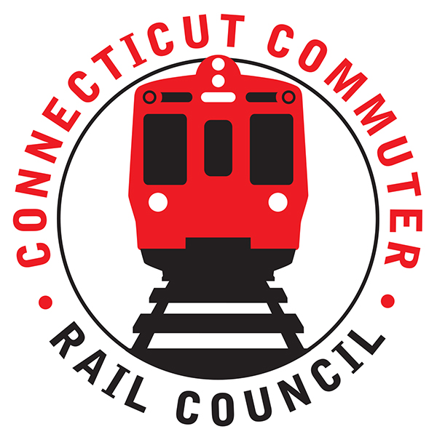

**AGENDA**

**Wednesday, February 17, 2021 – 7:00 PM**

**Via Zoom Video Conference (info below)**

|  |  |  |  |
| --- | --- | --- | --- |
| **1.** | **Welcome, introductions** | **Chair** | **7:00 p.m.** |
| **2.** | **Approval of December minutes** | **Council** | **7:02 p.m.** |
| **3.** | **Public Comments – 3 minutes each** | **Public** | **7:04 p.m.** |

**COUNCIL BUSINESS:**

|  |  |  |  |
| --- | --- | --- | --- |
| **1.** | **M8 PTC Software Performance Issues** | **MNR** | **7:10 p.m.** |
| **2.** | **Main Line and Branch Service** | **MNR** | **7:30 p.m.** |
|  |  |  |  |
| **3.** | **Hartford Line & Shoreline Issues** | **CDOT** | **7:40 p.m.** |
|  |  |  |  |
| **4.** | **CT Rides Return to Work Survey Results** | **CT Rides** | **7:50 p.m.** |
|  |  |  |  |
| **5.** | **Annual Meeting Schedule** | **Council** | **8:35 p.m.** |
|  |  |  |  |
| **6.** | **Annual Meeting Report** | **Council** | **8:45 p.m.** |
| **7.** | **Adjourn** | **Council** | **8:50 p.m.** |

**NEXT MEETING: March 17, 2021**

**To Be Determined**

