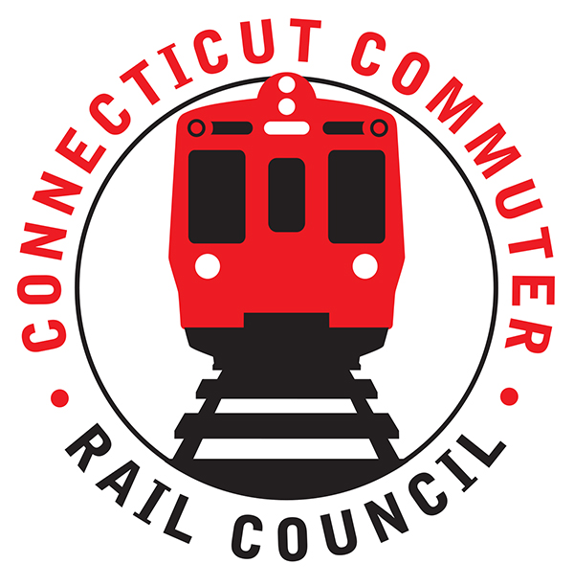

**Connecticut Commuter Rail Council**

**Wednesday, December 30, 2020 – 7:00 PM**

**Via Video Conference**

The following Council Members were in attendance by video conference: Jim Gildea, Jeff Maron, Terry Borjerson, Sue Prosi, Doug Hauslauden, Peter Garneau, and Roger Cirella.

The following people also attended by video conference: James Carlson, Amtrak; Rich Jankovich, CDOT; John Foster, CDOT; Ben Cornelius, MNRR; Mike Foglio, MNRR; David Florio, MNRR; Miriam Grossman, and Zell Steever.

The November 2020 minutes were approved.

**Public Comments:**

Miriam Grossman, a commuter is concerned about the lack of mask enforcement on trains and in rail stations. Rich Jankovich said masks are being handed out on trains. Rich said he sees mask compliance. Miriam is specifically concerned about Union Station. Rich said next time a conductor should be notified and the MTA police will enforce it.

Brian Friedman, a commuter had a question about his mail and ride account. He tried contacting customer service and wasn’t able to speak to a live operator. He is concerned about ticket purchase options. Mike Foglio, the director of GCT Station operations said he his account balance will not expire. Mike said he would follow up with him after the meeting.

**COUNCIL BUSINESS:**

1. **GCT Discussion with MNR Customer Service & Stations and Jones, Lang Lasalle (JLL):**

David Florio discussed the status of businesses in Grand Central Station. Business hours for the station businesses have been relaxed due to the covid pandemic. Sales have dropped seventy (70) percent in some instances. Tenants will have to be nimble for some time. Businesses will begin to reopen in 2021. Take out service is working for many of the food establishments. The waiting room in GCT is currently closed. Window twenty-eight (28) will be open to assist commuters until mid-January.

1. **MTA Ridership Projections 2021:2-week ridership trends update:**

A best case scenario for the return to ridership would be seventy (70) percent by year-end, 2021. Ridership is expected to return to eighty-five (85) percent by the end of 2022 and ninety-five (95) percent by 2023. A full return to ridership is not expected. The Waterbury Line is currently at forty-four (44) percent of regular ridership. Many commuters on the Waterbury Line do not have the option of working remotely. Rich Jankovich said there are still many unknowns about what ridership will look like after the pandemic. There is a concern that many commuters will only return to work two (2) to three (3) days a week. Ridership is currently at twenty-one (21) percent of normal.

1. **Main line issues – questions for MNR:**

MNR was asked about a recent email alert that informed riders that a train was canceled due to a shortage of equipment. Ben Cornelius said that a stand by train simply was not available. Jeff Maron said that the alert may be confusing to customers.

1. **Branch Line Issues – questions for MNR:**

Jim Carlson said M8 testing continues on the Shoreline. This is good news for CDOT. M8 testing will continue in 2021.

The Council adjourned at 8:18pm.

Respectfully submitted,

|  |  |  |  |  |  |
| --- | --- | --- | --- | --- | --- |
| Roger J. Cirella, Secretary |  | |  | |  |
|  |  | |  | |  |
|  |  | |  | |  |
|  |  | |  | |  |
|  |  | |  | |  |
|  |  | |  | |  |
|  |  | |  | |  |
|  | |  | |  | |