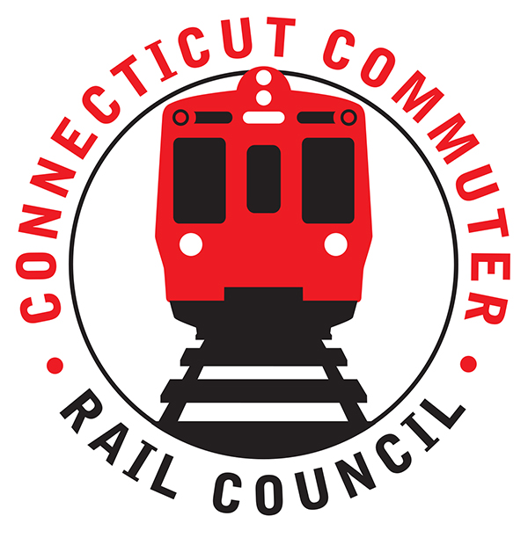

**Connecticut Commuter Rail Council**

**November 18, 2020**

The following Council Members were in attendance by video conference: Jim Gildea, Jeff Maron, E.C. Schroeder, Sue Prosi, Doug Hauslauden, Peter Garneau, and Roger Cirella.

The following people also attended by video conference: James Carlson, Amtrak; Rich Jankovich, CDOT; John Foster, CDOT; Mike Donnarumma, MNRR; Dave Melillo, MNRR; Jim Heinbecker, MNRR; Ben Cornelius, MNRR; Miriam Grossman, and Zell Seever.

The October 2020 minutes were approved.

**Public Comments:**

Miriam Grossman, a commuter said she was concerned about the availability of hand sanitizer at Shore Line East stations. Also, Miriam said there were no signs pointing to where sanitizer could be found. Rich Jankovich said CDOT will contact those station owners.

1. **PTC Implementation Status:**

Dave Melillo said M-8’s will be ready for PTC implementation later in November and December. The M-8 software testing has been completed. Metronorth will meet the compliance deadline in 2020.

1. **Car & Station Sanitizing:**

Jim Heinbecker said cars are disinfected every day. Metronorth said they are looking for a nonflammable cleaning product. Cleaning products are in high demand and so are difficult to obtain. Jim Gildea asked about the air quality on the trains. The HVAC system uses a MERV 8. Metronorth is testing a MERV 9 filtration system. The air filtration system uses a high tense, dielectric field. It is similar to a smoke eater. Rail cars are disinfected every day. Each M-8 rail car has a fresh air damper. There are twelve (12) air exchanges per hour on each rail car.

1. **M8 Tests on SLE for future operation:**

Power draw testing will occur on the Shoreline in December. Acceptance testing will occur in the 3rd week of December to February 2021. Progress is being made.

1. **2-week ridership trends update:**

Ben Cornelius said ridership has been increasing from summer to Labor Day. Ridership was highest in October 2019. Metronorth is currently at twenty-one percent (21%) of normal ridership. The lowest ridership count was six percent (6%) of normal ridership.

Jeff Maron said commuters are driving to New York City. Companies are encouraging employees not to use mass transit. Jim Gildea asked if there was a plan to attract riders later. Metronorth said they have been asked to work up promotions but they are waiting on a vaccine and are planning to ride it out to the Spring. Metronorth is predicting seventy percent (70%) office occupancy in 2024. People will more than likely work three (3) days a week and telecommute the other two (2) days.

1. **WBL Project status:**

Dave Melillo said cable plowing was done on the branch. Thirty (30) of the forty-seven (47) signal locations have been completed. Two (2) passing sidings have been completed. The first passing siding heading towards Waterbury is in Ansonia/Derby and the other is in Beacon Falls.

Catenary work will be completed on the Devon Bridge so there will be some off peak outages for the branch.

1. **Main line issues – questions for MNR:** Nothing to report.
2. **Branch Line Issues – questions for MNR:** Nothing to report.
3. **Adjourn:**

The Council adjourned at 8:24pm.

Respectfully submitted,

|  |  |  |  |  |  |
| --- | --- | --- | --- | --- | --- |
| Roger J. Cirella, Secretary |  | |  | |  |
|  |  | |  | |  |
|  |  | |  | |  |
|  |  | |  | |  |
|  |  | |  | |  |
|  |  | |  | |  |
|  |  | |  | |  |
|  | |  | |  | |