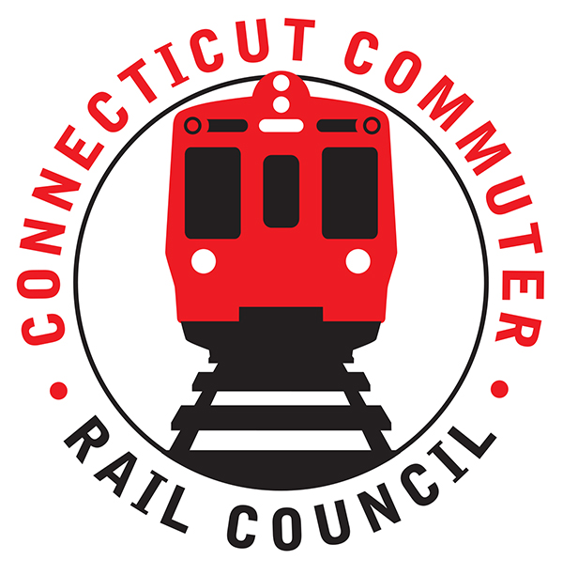

**Connecticut Commuter Rail Council**

**October 21, 2020**

The following Council Members were in attendance by video conference: Jeff Maron, E.C. Schroeder, Sue Prosi, Doug Hauslauden, Peter Garneau, and Roger Cirella.

The following people also attended by video conference: Richard Jankovich, CDOT; John Longobardi, MNRR; Sue Doerning, MNRR; Jim Carlson, Amtrak; Tom McCarthy, CT Rail, and Miriam Grossman.

**Public Comments:**

Miriam Grossman, a commuter is concerned about passengers wearing masks. Miriam also said there was a lack of sanitizer on the trains. Miriam is not comfortable commuting. Miriam also said there is no follow up when she places complaints. Sue Doerning said we do respond. Filed complaints have reference numbers. Sue said we will bring her issue to customer service’s attention.

1. **MNR workforce availability due to COVID and vacancies due to hiring freeze:**

Sue Doerning said ten (10) percent of the employees were out in April, 2020. Overall, there has been good attendance during the pandemic. MNR averages four (4) percent of employees out sick. The availability of employees is good.

1. **Mask Compliance post fine implementation:**

John Longobardi is in charge of the conductors. Conductors are messaged about making mask announcements on the train. Trains have one (1) conductor and one (1) assistant conductor.

1. **2-week ridership trends update:**

Ridership has been twenty-two (22) to twenty-six (26) percent of pre-covid levels. Week day ridership averages about twenty-three (23) percent of pre-covid levels and about fifty (50) percent of pre-covid levels on the weekends. Ridership is continuing to improve.

1. **Service level changes based on ridership update:**

Sue Doerning said MTA is evaluating next steps in managing reduction in service and social distancing. Rich Jankovich said the CDOT commissioner and the MTA president are discussing this. They are looking at data every day. Jeff asked whether Governor Lamont had any input on this. Rich Jankovich said he cannot speak to it.

1. **New M8 delivery status:**

John Longobardi said the M-8’s are arriving. They are back on schedule and MTA will start testing. Rich Jankovich said M-8 testing is still ongoing on the Shoreline. COVID has affected progress.

1. **Main Line Issues-Questions For MNR:**

Ridership was lost in the financial district. Ridership is better on the Waterbury Line because many commuters are essential workers. There is a concern that riders may not return. Commuters may come in three (3) days a week. There are no baseball games and the theaters are closed so all of this affects ridership.

1. **Branch Line Issues-Questions for MNR:**

On the Hartford Line, Rich Jankovich said people are returning. Tom McCarthy has seen a progressive uptick in ridership. The busiest days are Friday and Saturday. Companies are slowly returning to work. TASI is expecting an uptick around Thanksgiving.

On the Shoreline, E.C. Schroeder mentioned the morning commute times need improvement.

1. **Adjourn**

The Counsel adjourned at 8pm.

Respectfully submitted,

|  |  |  |  |  |  |
| --- | --- | --- | --- | --- | --- |
| Roger J. Cirella, Secretary |  | |  | |  |
|  |  | |  | |  |
|  |  | |  | |  |
|  |  | |  | |  |
|  |  | |  | |  |
|  |  | |  | |  |
|  |  | |  | |  |
|  | |  | |  | |