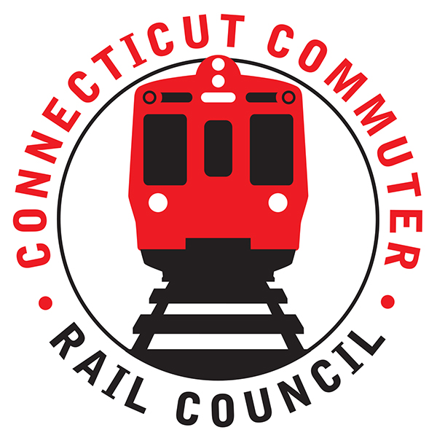

**Connecticut Commuter Rail Council**

**June 17, 2020**

The following Council Members were in attendance by video conference: Jim Gildea, Jeff Maron, Peter Garneau, Sue Prosi, Doug Hauslauden, Mike Mahoney, Melissa Kane, Terry Borjerson, and Roger Cirella.

The following people also attended by video confernece: Richard Jankovich, CDOT; Jon Foster, CDOT; Marcy Peterson, CDOT; John Kesich, MNRR; Mike Donnarumma, MNRR; Glen Hayden, MNRR; David Melillo, MNRR; Roger Senserich, MNRR, James Carlson, Amtrak, Robert Hale, and Zell Steever.

Jim Gildea thanked Glenn Hayden for all his work. David Melillo will be replacing Glenn after his retirement. A motion was made and seconded by Sue Prosi to commend Glenn Hayden.

A motion was made to approve the May 2020 minutes and seconded by Melissa Kane. The May 2020 minutes were approved.

There were no public comments.

**Council Business**:

**New Haven/Branch Line ridership levels**:

There are approximately one hundred fifty (150) riders on the Waterbury Line and one hundred twenty-five (125) riders on the Danbury Line. On the main line, there are approximately seven thousand two hundred (7,200) riders.

**New Haven/Branch Line future service plans**:

There are currently eight (8) car sets in service now. MNRR will continue to monitor ridership and will plan accordingly.

Mike Mahoney mentioned that he would like to see train setts as long as possible. Mike Donnarumma said some platforms are a problem such as the East Norwalk station. Jeff Maron asked MNRR to keep the Council posted on ridership.

**Rail Car Air Filtration**:

Prior to the pandemic, rail cars were on a twenty-four (24) to forty-eight (48) hour schedule. Today, rail cars run through a twelve (12) hour cycle. All touch points are being cleaned. There are hand sanitizers on the train platforms.

Mike Donnarumma said there was an incident with a commuter refusing to wear a mask in New Rochelle. Conductors make announcements regarding the mask policy. Overall, most commuters have been good. Jim Gildea asked if the police would be called over the mask policy. Mike Donnarumma said it would depend on the commuter’s actions. There are surgical masks in the head car or rear car of each train set for commuters.

**Main Line Issues**:

Glen Hayden said MNRR has taken advantage of the outage to complete construction. MNRR has gained two (2) to three (3) months of track construction during the outage. Glenn said by the end of the third quarter, all PTC equipped trains will be running in PTC. By the end of the year, trains will be PTC equipped at the head end and rear end of the train sets.

**Branch Line Issues**:

On the Waterbury Branch, a PTC contractor has been working on the PTC project. Nine thousand (9,000) ties have been installed on the Waterbury Branch. Service will resume in September on the Waterbury Branch and late July on the Danbury Branch.

Glen said the PTC project will be finished by mid-2021. Jim Gildea asked if CDOT will have equipment to run additional service once the PTC project is finished Rich Jankovich said we can look for equipment but there are budget issues that the State of Connecticut has to address. Jim asked if the commuters can take advantage of the passing sidings once the entire project is finished in 2022. Rich said CDOT is looking at it.

**SLE/Hartford Line Ridership Levels:**

Ridership has been increasing on the Hartford Line compared to SLE. Additional shuttles were added on the Hartford Line on June 1st.

**SLE/Hartford Line Future Service Plans:**

Rich Jankovich said the ridership numbers are increasing on the Hartford Line.

On SLE, CDOT will work with Amtrak to add service as the ridership numbers increase.

**SLE/Hartford Line Issues:**

On the Hartford Line, a conductor had a confrontation with a commuter on a train to Hartford. A commuter allegedly spit at a conductor. CDOT will being conducting their own investigation.

Adjourned at 8:03pm.

Respectfully submitted,

Roger J. Cirella, Secretary