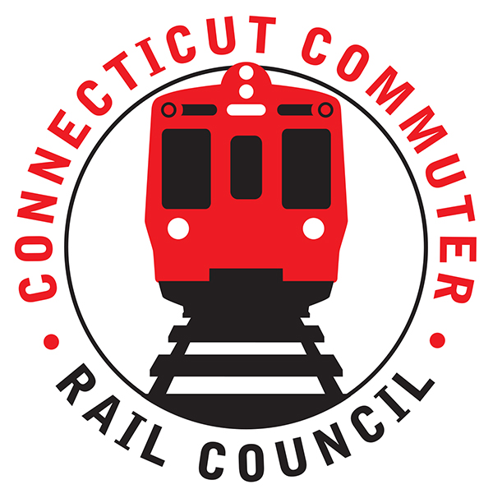

**Connecticut Commuter Rail Council**

**July 15, 2020**

The following Council Members were in attendance by video conference: Jeff Maron, Terry Borjeson, Peter Garneau, Sue Prosi, Mike Mahoney, Doug Hauslauden, and Roger Cirella.

The following people also attended by video conference: John Longobardi, MNRR; Mike Donnarumma, MNRR; Mike Schiffer, MNRR; Jon Foster, CDOT; Tom McCarthy, Amtrak, and Rich Jankovich, CDOT.

The June 2020 minutes were approved.

**Council Business**:

1. **New Haven/Branch Line ridership levels**:

For June 2020, ridership was down ninety (90) percent on the main line compared to 2019.

1. **New Haven/Branch Line future service plans**:

Mike Schiffer said Metronorth has their eyes set on Labor Day. Metronorth still has the flexibility to add trains. Mike Schiffer of MNRR said a survey is being done for the entire Metronorth territory. There has been a very slow progression of riders returning to trains. About half of riders can work from home. Companies in New York are looking to reduce their footprint.

Service has resumed on the Danbury Line. Rail service is planned to return on the Waterbury Line in mid-September.

1. **Maintenance Project Updates**:

On the Danbury Line, fourteen thousand (14,000) ties have been replaced and two hundred (200) transmission towers have been removed.

A plow train will be starting work on the installation of the signal system on the Waterbury.

PTC is being cut in on the eastern end of New Haven. There has been good progress on PTC. Metronorth has taken advantage of reduced service to complete maintenance projects.

Work on the Walk Bridge is progressing. New switches are being installed and drainage work is being completed.

1. **Main Line Issues**:

Parking fees at the Stamford garage have resumed effective July 1, 2020. A credit will be issued to parking permit holders for the last three (3) months. There will be no refunds, only credits.

1. **Branch Line Issues**:

See Agenda item #7.

1. **SLE/Hartford Line Ridership Levels:**

Ridership has been slow to return on SLE. Three (3) more trains have been added on the Hartford Line.

1. **CDoT issues with passenger fare evasion/ behavior:**

Rich Jankovich said CDOT will receive assistance from the State and Local Police when these situations occur. TSA had presence at the Hartford station including the use of police dogs.

Mike Donnarumma said conductors have begun collecting cash on board including Waterbury buses. Conductors have been assaulted, spit on, and had liquids thrown at them. There was an incident at the Waterbury Station where a conductor was assaulted. The Council will promote a safe ride through social media. Mike Mahoney asked if wearing masks on board trains can be enforced. John Longobardi said Metronorth has not entertained enforcing passengers to wear masks. Mike Donnarumma said front and rear cars of train sets have a fifty (50) count box of masks for passengers.

1. **SLE / Hartford line future service plans:**

Labor Day is being watched for a possible service increase.

1. **SLE/Hartford Line Issues:**

There have been few issues with masks. Commuters have been good.

Adjourned at 8:10 pm.

Respectfully submitted,

Roger J. Cirella, Secretary