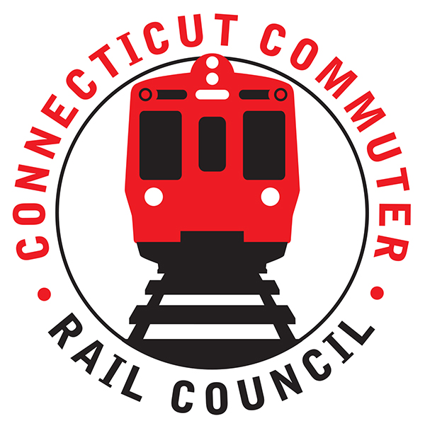

**AGENDA**

**Wednesday, July 15, 2020 – 7:00 PM**

**Via Video Conference**

|  |  |  |  |
| --- | --- | --- | --- |
| **1.** | **Welcome, introductions** | **Chair** | **7:00 p.m.** |
| **2.** | **Approval of June minutes** | **Council** | **7:02 p.m.** |
| **3.** | **Public Comments – 3 minutes each** | **Public** | **7:04 p.m.** |

**COUNCIL BUSINESS:**

|  |  |  |  |
| --- | --- | --- | --- |
| **1.** | **New Haven / Branch line ridership levels** | **MNR** | **7:10 p.m.** |
| **2.** | **New Haven / Branch line future service plans** | **MNR** | **7:20 p.m.** |
|  |  |  |  |
| **3.** | **Maintenance Project Updates** | **MNR** | **7:30 p.m.** |
| **4.** | **Main line issues** | **MNR** | **7:45 p.m.** |
|  |  |  |  |
| **5.** | **Branch line issues** | **MNR** | **7:55 p.m.** |
|  |  |  |  |
| **6.** | **SLE / Hartford line ridership levels** | **CDOT** | **8:05 p.m.** |
|  |  |  |  |
| **7.** | **CDoT issues with passenger fare evasion/ behavior** | **CDOT** | **8:15 p.m.** |
|  |  |  |  |
| **8.** | **SLE / Hartford line future service plans** | **CDOT** | **8:25 p.m.** |
| **9.** | **SLE / Hartford line issues** | **CDOT** | **8:35 p.m.** |
|  |  |  |  |
| **10.** | **Adjourn** | **Council** | **8:45 p.m.** |

**NEXT MEETING: August 19, 2020**

**Site: TBD**

**Call in information:**

