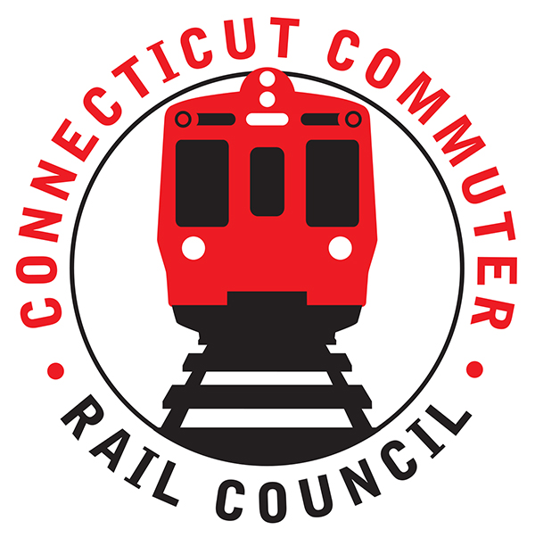

**Connecticut Commuter Rail Council**

**May 20, 2020**

The following Council Members were in attendance by phone: Jim Gildea, Jeff Maron, Peter Garneau, E.C. Shroeder, Sue Prosi, Mitch Fuchs, Melissa Kane, and Roger Cirella.

The following people also attended by phone: Richard Jankovich, CDOT; Jon Foster, CDOT; Marcy Peterson, CDOT; John Kesich, MNRR; Mike Donnarumma, MNRR; Glenn Hayden, MNRR; and James Carlson, Amtrak.

The April minutes were approved. Sue Prosi and Mitch Fuchs abstained from the vote.

Public Comments: David Rivera, a commuter on the Hartford Line said the trains are clean and the service has been good.

New Haven/Branch Line Ridership Levels:

John Kesich said there was normal service into March. After the pause mandate by Governor Cuomo, ridership fell precipitously. Riders are essential workers.

In April, it was a ghost town on all three rail lines. The majority of the rail cars had one passenger per car. Today, there are approximately ten passengers per car. Ridership is now down ninety-four (94) percent.

New Haven/ Branch Line future service plans:

The plan is to increase service the second half of June. Service is running ninety-eight (98) percent on time. John Kesich said they are working to keep trains one-third full for social distancing. A question was asked if conductors would enforce commuters to wear masks. The commuters have been good about wearing masks.

Sue Prosi asked if fares are being charged and John Kesich said all travel is being charged at an off peak rate. Melissa Kane asked about the future of rail travel. John said there is a significant crisis with rolling stock and infrastructure. People’s travel patterns will change. MTA is gathering data to predict future. An increase of service will be similar to early April and MLK holiday schedule. Social distancing will remain for some time.

Glenn Hayden said there will be busing on the Danbury Branch. An eight (8) week outage is planned where twelve thousand (12,000) ties will be replaced.

On the Waterbury Branch, eight thousand (8,000) ties will be replaced. Steel repairs have been made on three (3) bridges. Cable trays have been installed for the signal system. Metronorth is taking full advantage of the down time to complete construction projects. A month or two may be gained during this down time to complete the PTC project.

For PTC, Metronorth is well poised to make deadline. There are some issues with the M-8 software.

SLE / Hartford Line ridership levels:

There are currently eight (8) round trips a day. Passengers are wearing masks.

SLE/Hartford Line future service plans:

On June 1, 2020, two (2) trains will be added to the schedule and there will be one (1) service adjustment.

|  |  |
| --- | --- |
| Covid costs, budget issues and impact to capital projects:  CDOT is monitoring revenue loss and pursuing federal money.  Shoreline East Upgrade Proposal from Commuter:  A motion was made and seconded by Peter Garneau to submit the Zell Steever letter from the CCRC to the CT legislature.  Adjourned at 8:07pm.  Respectfully submitted,  Roger J. Cirella   |  | | --- | |  | |