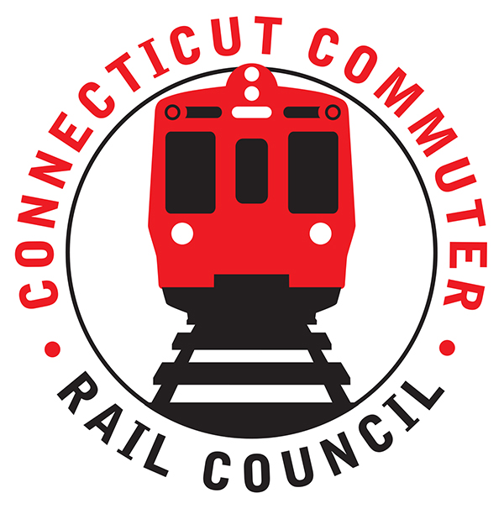

**Connecticut Commuter Rail Council**

**April 15, 2020**

The following Council Members were in attendance by phone: Jim Gildea, Peter Garneau, Terry Borjeson, Doug Hausladen, Mike Mahoney, E.C. Shroeder, and Roger Cirella.

The following people also attended by phone: Jim Carlson, Amtrak; Gerald Caturano, Amtrak; Richard Andreski, CDOT; Richard Jankovich, CDOT; Jon Foster, CDOT; Marcy Peterson, CDOT; David Sax, and Zell Steever.

Public Comments: None.

1. Shoreline East CoVid 19 current service and future plans CDOT

Rich Andreski said ridership is down 85-90% on the railroad and 50-60% on buses. Rich Jankovich said CDOT will be reducing service on the Shoreline starting on April 20, 2020. Jim Gildea asked about the protocol for cleaning the trains. Marcy Peterson said trains are being sanitized once a day. Rail cars are deep cleaned every other day.

On the Hartford Line, several trains will be cut including Amtrak service. For example, trains 4452, 4453, 4458, 4461, and 4463 will be cut from service. Amtrak trains 475 and 476 will also be cut.

Jim Gildea asked about a re-start. Rich Jankovich said CDOT will be looking for trends. Train service will be restored once ridership returns. Since the State of Connecticut is essentially closed until May 20th, trends will not likely change.

There was a twitter question about the status of the P-40’s. Marcy Peterson said six (6) locomotives are out for overhaul. Two (2) more locomotives will go out for overhaul when two (2) return. There are three (3) in a production line at a time. Once a locomotive is returned from overhaul, it goes through extensive testing before it is returned to service. There are eighteen (18) locomotives, six (6) GP40’s and twelve (12) P40’s.

1. Shoreline East Fleet Procurement Plan CDOT

Rich Andreski said there will be sixty (60) rail cars at a cost of 300 million. The earlier plan called for seventy-two (72) rail cars, twelve (12) of which would have been utilized on the Waterbury Line. The Bond meeting is scheduled for April 16, 2020. The sixty (60) cars will be used on the Shoreline and Hartford Line. Jim Gildea said the Waterbury Line is currently under a major infrastructure project but the improvements cannot be utilized without additional equipment.

1. Shoreline East M8 Testing Update CDOT

Marcy Peterson said the meetings with Amtrak continue. Rich Andreski said there are two (2) components here, one is the technical work and the other is the business relationship with Amtrak. Acela service is expanding and the focus has been on the Hartford Line. Bandwidth is also an issue on the Shoreline. Jim Gildea asked if there was a need to run M8’s if sixty (60) new cars are coming. Rich Andreski said he would like to see through trains from Stamford.

1. Shoreline East Service Performance Review

Jim Carlson said continued track maintenance and the locomotive overhauls have contributed to better service.

1. Shoreline East Upgrade Proposal from Commuter Council

Zell Steever made a power point presentation to the Council where a new branch line would be created. P&W freight line tracks would be utilized. Service would extend from Old Saybrook to Rhode Island. Rail service would increase from centers of industry. Traffic congestion could be reduced on I-95 and I-395. Zell noted that thirty-eight (38%) of greenhouse gases come from transportation. Jim Gildea asked how the Council be helpful. Zell would like a letter supporting the project. Zell also said that Electric Boat is having problems recruiting employees. The current employees are commuting from far distances and a rail line would help them.

Rich Jankovich mentioned the 100th anniversary of Union Station is approaching. A full scale event is planned. Also, a train horn blow is scheduled for 3:00pm on April 16th to salute transit workers working during the pandemic.

Adjourned at 7:37pm.

Respectfully submitted,

Roger J. Cirella, Secretary