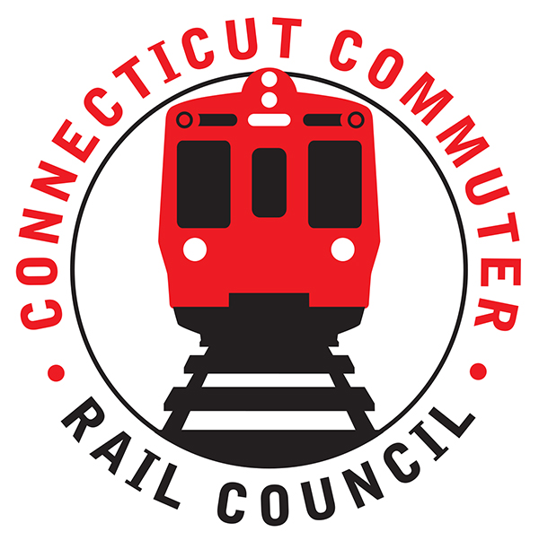

**Connecticut Commuter Rail Council**

**March 18, 2020**

The following Council Members were in attendance by phone: Jim Gildea, Jeff Maron, Peter Garneau, Sue Prosi, Mitch Fuchs, Terry Borjeson, Doug Hausladen, Mike Mahoney, E.C. Shroeder, Melissa Kane, and Roger Cirella.

The following people also attended by phone: Glenn Hayden, MNR; John Kesich, MNR; Justin Vonashek, MNR; and Richard Jankovich, CDOT.

Public Comments: None.

Council Business:

February 2020 minutes were approved.

1. CoVid 19 Response and Planning

John Kesich said ridership is down ninety (90) percent. This decline was precipitated by the corona virus. MNR is cleaning and disinfecting rail cars. MNR employees are using Lysol and Lysol wipes. The virus is spread through coughing and sneezing. All the rolling stock and buses are cleaned every seventy-two (72) hours. New York State recommends running service so essential personnel can get to their jobs. Amtrak and CDOT are running on a Saturday schedule. There are no CoVid 19 cases among MNR employees at this time. Cash sales have been suspended except at TVM locations. Jeff Maron thanked MNR for their service and for stepping up to meet this crisis. There was a question from twitter regarding ticket refunds. John said there were no changes in refund policy.

Jim Gildea asked about MNR funding. John said MNR customers cover half of operating expenses. The other half comes from subsidies. For example, the gas tax and the real estate conveyance tax are used to make up the difference.

John said MNR is trying to avoid employee furloughs. Employees can be re-assigned to other tasks.

1. PTC Implementation Status

Glenn said the Harlem and Hudson Line are entirely in PTC. The Danbury Branch is in PTC and the New Canaan Line is in RSD. MNR is still working on the New Haven Line specifically CP 273 and CP 274. Between today and this July, the M8 fleet will be equipped with software and the software will be tested in July. The freight lines such as P&W and CSX will utilize PTC by this summer.

1. Main Line Issues-Questions For MNR

John Bernick said service is operating above goal. The mild weather has helped. Glenn said work has not slowed down. Welded rail has recently been installed in Rowayton.

1. Branch Line Issues-Questions For MNR

The work projects will impact branches. There is significant work scheduled for the Waterbury Branch. The cab signal and PTC system will be state of the art on the Waterbury. There is catenary work scheduled in Devon.

1. Adjourn

Jeff said the customers appreciate MNR.

Melissa Kane made a motion to adjourn that was seconded by Doug Hausladen and the meeting adjourned at 6:40pm.

Respectfully submitted,

Roger J. Cirella, Secretary