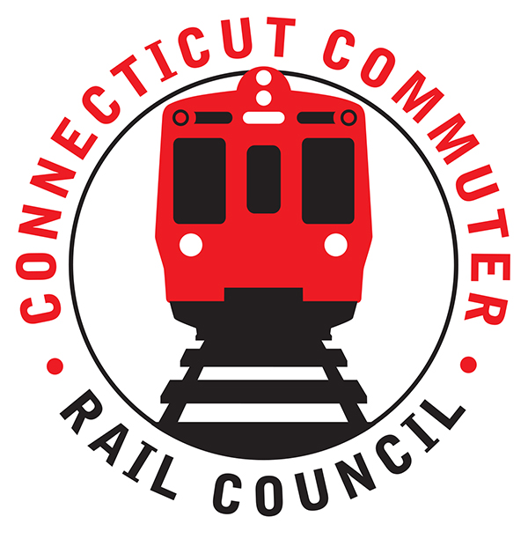

**Connecticut Commuter Rail Council**

**February 19, 2020**

The following Council Members were in attendance: Jim Gildea, Jeff Maron, Peter Garneau, Sue Prosi, and Roger Cirella.

The following Council Members attended by phone: Mike Mahoney and Melissa Kane.

The following people were in attendance: Mike Donnarumma, MNR; Glen Hayden, MNR; Ben Cornelius, MNR; Marcus Little, MNR; Omaira Santiago, MNR; Esther Giordano, Zell Steever, Giacomo Landi, Richard Jankovich, CDOT; and Representative Matt Blumenthal, CGA.

Public Comments: Esther Giordano, a commuter presented the Council with an elevator system for the Stamford train station. Multi, is a rope-free elevator system that also moves sideways. The Council suggested that Esther reach out to the City of Stamford with this new elevator system.

Zell Steever from Groton, CT asked about extending service on the Shoreline East to Rhode Island. Jim Gildea said it will be discussed at the meeting next month. Service would be extended south east from New London. There is a freight line that runs on the East side of the river. Representative Courtney would be the legislator to contact for more information.

Council Business:

1. Delivery of 66 new M8 Cars:

Glen Hayden said there is a nine (9) month delay. The schedule has a delivery date by 2021. There is a delay in training new workers. The new rail cars will be shipped from Lincoln, Nebraska. The cars are scheduled to be delivered from July 2020-March 2021.

1. ROI for Rail Equipment and Rail Procurement Update:

Rich Jankovich said CDOT will look nationally for rail equipment. Currently, CDOT is looking in Florida and Illinois. Once equipment is located, rounds of inspections will begin. The Hartford Line currently needs three (3) to six (6) additional rail cars. CDOT is now seeking 132 rail cars. Seventy-two (72) rail cars are now funded. Fifty (50) cars are not funded. Jim Gildea said the Waterbury will need twelve (12) cars. Two (2) sets are needed in the morning and two (2) sets in the evening. Rich said six (6) P40’s are currently being overhauled. There is a six (6) week delay in the overhaul of the GP40’s due to the exhaust systems being rebuilt.

1. Main Line Issues:

Glenn Hayden said MNR is taking advantage of the mild weather. Regarding PTC, the entire Hudson and Harlem Line will be in RSD, revenue service demonstration. In March, the wayside for New Canaan will be in RSD. On the New Haven Line, various sections will be cut in for PTC. There may be a delay in full PTC due to the corona virus. The alstrom boards are being manufactured in Singapore. Currently, the M8’s are not ready for PTC. The current PTC completion date is November 2020.

1. Branch Line Issues:

The siding in Beacon Falls will be installed this year on the Waterbury Line.

On the New Canaan Line, Giacomo Landi, a commuter spoke about conditions on the Branch and the need for additional service and parking. Representative Blumenthal spoke about funding for a rail siding on the New Canaan Branch. Jim Gildea said the Council will contact John Bernick at CDOT and will be in touch.

1. Shoreline East Issues:

The Council is scheduled to meet on the Shoreline next month.

1. Election of Officers

The current officers were re-elected.

1. Annual Report

The report will be submitted to the legislature next month.

1. Adjourn

January 2020 minutes were approved.

Adjourned at 8:38pm.

Respectfully submitted,

Roger J. Cirella, Secretary