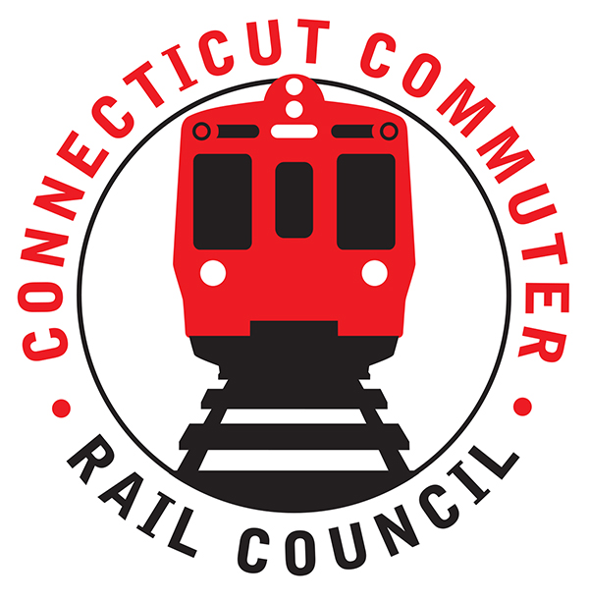

**Connecticut Commuter Rail Council**

**January 15, 2020**

The following Council Members were in attendance: Jim Gildea, Peter Garneau, Doug Hausladen, E.C. Schroeder, Terry Borjeson, Melissa Kane, Mitch Fuchs, and Roger Cirella.

The following Council Members attended by phone: Jeff Maron.

The following people were in attendance: Joe Giulietti, CDOT Commissioner; Rich Andreski, CDOT; Richard Jankovich, CDOT; Carl Jackson, CDOT; Jonny Dach, Office of the Govenor; Nick Simmons, Office of the Governor; Vicki Shotland, GHTD; Roger Senserrich, WFP; Thomas McCarthy, TASI/ACI; Thomas Mik, TASI/ACI; and Joe Traca, Acre 9 MTA.

Public Comments: None.

Council Business:

December 2019 minutes were approved.

1. Governor’s Transportation Initiatives:

Jonathan Dach from the Governor’s office said the toll bill was meant for a funding mechanism for transportation. At the moment, the legislature is looking at tolling heavy trucks on select bridges. The bill anticipates netting 170 million dollars in revenue for transportation. Joe Giuletti said there is a possibility of netting 235 million dollars with tolling additional bridges. This anticipated revenue will free up funding for transportation projects.

1. Improving Cell Phone Coverage on Rail Lines:

Nick Simmons said 4G will be increased in the short term. There is a public/private partnership with AT&T. Rich Andreski said AT&T has been very cooperative. Currently, AT&T is the only carrier. 5G devices are not on the market yet. The focus for 5G will be the mainline and then on the branches. The State is not paying for anything. The Carrier is paying for the installation.

1. Hartford Line Update: (update, timing, service)

There was a question regarding the bathrooms in Union Station. The bathrooms will be expanded. The funding is there. The bathrooms were renovated ten (10) years ago.

Rich Andreski said CDOT is way ahead of their goals on the Hartford Line. There is economic development now on the Hartford Line. This is happening with limited service.

The top speed on the Hartford Line is now 110 miles per hour. CDOT is working on a connection to Bradley Airport. CDOT is very pleased with the vendor, Transit America.

Tom from Transit America said they are surprised with the demand for service. Eight (80) percent of the ridership is between New Haven and Hartford. Tom said the equipment on the Hartford Line is over forty (40) years old. Transit America would like to see the old equipment replaced with new equipment.

A question from Twitter asked about the possibility of expanding service to Springfield, MA. Service is shared with the freights and Amtrak but after the line is double tracked to Springfield, it is possible to add service. Service has been expanded to Windsor Locks.

The Commissioner said the State must connect the airport with the Hartford Line. CDOT said the line must be completely double tracked and more rail cars added.

1. Update Council on Transportation Committee Meeting: (if held)

Jim Gildea said the legislators want communication. Currently, the parking tax may not be implemented. The legislators are the third leg in improving rail transportation. Terry Borjeson said he thought this was the best meeting yet with our legislators. Jim said we need to create a communication vehicle with our legislators.

1. Update Council on WBL Meeting (if held)
2. Annual Report
3. Annual Meeting Schedule: The June meeting will be held in Hartford.

Adjourned at 7:17pm.

Respectfully submitted,

Roger J. Cirella, Secretary