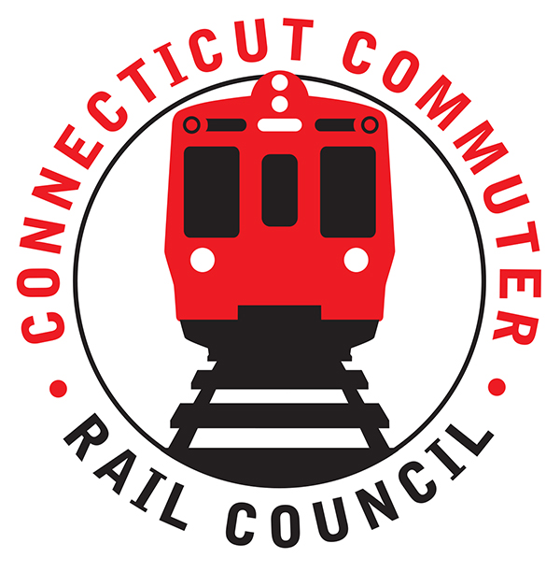

**Connecticut Commuter Rail Council**

**December 18, 2019**

The following Council Members were in attendance: Jeffrey Maron, Peter Garneau, E.C. Shroeder, Doug Hausladen, Sue Prosi, Lisa Slinsky, and Roger J. Cirella.

The following Council Members attended by phone: Melissa Kane.

The following people were in attendance: Glen Hayden, MNR; Richard Jankovich, CDOT; Frank Pomes, MNR; and John Bernick, CDOT.

Public Comments: None.

Council Business:

November 2019 minutes were approved.

1. CT2030 Review and Discussion

John Bernick said CT2030 is dependent on the revenue coming into the STF. The original transportation proposal called for full tolling and full rail car additions to the rail lines. The original proposal also called for additional service, expansion of the Hartford Line, and high platforms on the Waterbury. These proposals all depend on revenue. Track speed improvement is a priority for the Governor.

State of Good Repair is a constant. The Walk Bridge is funded. The State of Good Repair is 4.3 billion over ten (10) years. Toll revenue can only be spent on roads that are tolled so money can be freed up for rail projects.

John Bernick also mentioned that electric vehicles are coming and the gas tax revenue is diminishing. The STF is going bankrupt. CDOT is going to need a new revenue source.

Jeff Maron asked about the Autonomous Vehicle Task Force. Rich Andreski is on that task force. Jeff asked how would this task force would fit in CT 2030? John said it would fall under station enhancements.

1. Hartford Meeting Discussion: No discussion.
2. Main Line Issues-Questions for MNR

Glen Hayden said MNR is basically on hiatus for the winter. There are currently no production crews out there.

For PTC, there is extended RSD on the Hudson Line. On January 18, a cut in of conduit for PTC is planned from Mt. Vernon to Brewster. In February, a PTC software update is planned on the M8’s. The current cab signal system fulfills 75% of the PTC requirement.

1. Branch Line Issues-Questions for MNR

Much work has been completed on the Danbury and Waterbury Branches. There is more work planned for 2020. Fiber will be plowed in for PTC on the Waterbury. The Beacon Falls siding installation is planned for 2021. By mid-2021, functional PTC will be installed on the Waterbury.

1. SLE & HL Issues-Questions for CDOT: No discussion.
2. CCRC Annual Report: No discussion.
3. 2020 Annual Meeting Schedule: No discussion.

Adjourned at 8:15pm.

Respectfully submitted,

Roger J. Cirella, Secretary