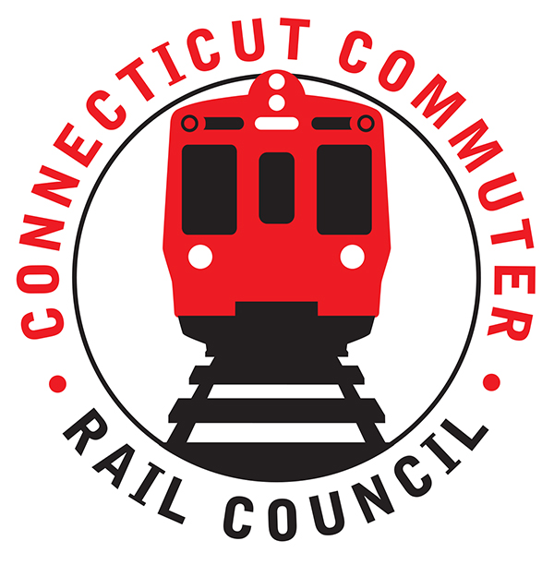

**Connecticut Commuter Rail Council**

**October 16, 2019**

**4th Floor Conference Room MNR Conf. Room A**

**50 Union Avenue**

**New Haven, CT**

The following Council Members were in attendance: Jim Gildea, Mitch Fuchs, Peter Garneau, Sue Prosi, Lisa Slinsky, Doug Hausladen, E.C. Schroeder, and Roger Cirella.

The following Council Members attended by phone: Terry Borgeson and Laura Cordes.

The following people were in attendance: Ken Motuzick, Kim Dunham, Greater New Haven T.D.; David Rivera, Norman Forrester, NHDA; Mike Donnarumma, MNRR; Joseph Traca, MNRR; Joe Giulietti, CDOT Commissioner; Rich Andreski, CDOT; Anstress Farwell, NH Urban Design League; Rick Wies, Pam Sucato, CDOT; Richard Jankovich, CDOT; Ed Pikaart, Robert Hale, Margaret Pikaart, Jason Senserrich, Aaron Goode, Moses Boone, Abigail Roth, New Haven Alderman; Hong Lu, Matt Tyksinski, and members of the public.

Public Comments:

David Rivera asked how much longer will the overhead wire project continue? Joe Giulietti said the project has been going on for thirty (30) years. Mike Donnarumma said MNRR labor is spread thin and there are issues with design.

A commuter asked about bikes on trains. Joe Giulietti said he is pro-bikes. There are rules that must be followed. The good news is that now there are cameras for any troublemakers.

Sixty-six (66) M-8’s have been ordered and will be arriving in pairs. There are no rail cars yet slated for the Danbury and Waterbury Lines.

A question was asked about returning bar cars to the New Haven Line. Joe Giulietti said he was a fan of the bar cars but there is simply too much growth to support bar cars. MNRR needs as many seats as possible.

Mitch asked Joe Giulietti about contingency plans when service is disrupted, for example the July 4th incident where service was reduced by 40%. Joe said he knew what happened. Mike Donnarumma said it was a capacity issue. It is very difficult to move trains quickly to meet service demand.

Council Business:

1. Commissioner Joseph Giulietti Transportation Overview and Rail Discussion.

Joe Giulietti said ridership numbers on the railroad keep growing. As Commissioner, he has to be a highway and rail guy. The catenary project has been going on for thirty (30) years. That is simply an unwillingness to invest in the railroad for so many years. Not long ago, the attitude was to by a car for every Waterbury commuter than to invest in the Waterbury Line. Now CDOT is building a signal system. The transportation fund is 40% debt service. Obviously, CDOT needs a new revenue source. CDOT does want to speed up service. Rail cars are in short supply.

1. New Haven Garage update

Joe Giulietti said we are re-evaluating the project. Everything is on the table including TOD.

1. Railcar Procurement Update

A commuter advisory panel (CAP) has been formed. Fifteen (15) commuters have been chosen. Each commuter represents a specific characteristic, e.g. diversity, handicapped, and pro-bike. The goal of the group will be to follow procurement of the new rail cars for the branches. Jim Gildea is on the panel and will keep the Council informed.

1. Update on Stamford Garage-maintenance of existing and status of planned new construction.

This topic will be addressed at the next meeting.

1. Main Line Issues-questions for MNR

Sue Prosi said the real time sign was incorrect this afternoon. Track 4 showed information for previous time periods. The MTA app would not download the real time information.

Sue was noted that pending retirements of MetroNorth and CTDOT employees would impact operations and the ability to manage programs and capital projects. Glenn Hayden said the president of MNRR is aware of the situation. Glenn Hayden said RSD (revenue service demonstration) has been implemented on the Danbury Line for PTC. A safety plan has been submitted to FRA.

1. Branch Line issues-questions for MNR

A question was asked whether the PTC project could be completed sooner than 2021 on the Waterbury. Glenn said no.

The outage on the Waterbury for two (2) weeks allowed MNRR to complete many projects for the implementation of signals and PTC.

E.C. Shroeder said he was pleased with service on the Shoreline lately. A question was asked about running M-8’s on the shoreline. Rich Jankovich said CDOT is moving forward.

1. Hartford Line SLE issues-questions for Amtrak

A commuter asked about the Hartford Line and why the Amtrak service is late. The Amtrak representative advised that the Amtrak trains originate south of New Haven and may face disruptions. Amtrak’s first concern is safety then on time performance.

Rich Jankovich hopes the State of Connecticut adds more service on the Hartford Line which would depend on funding. Rich Andreski said the success of the Hartford Line has been phenomenal.

Adjourned at 7:58pm.

Respectfully submitted,

Roger J. Cirella, Secretary