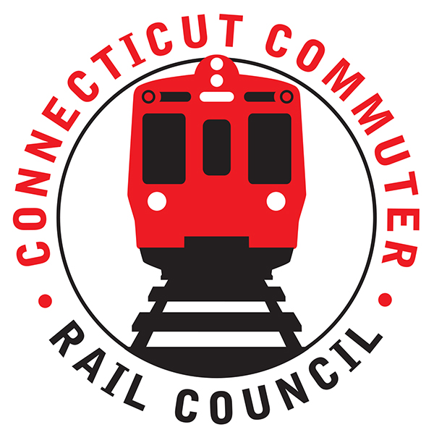

**Connecticut Commuter Rail Council**

**September 18, 2019**

**Inspection Car**

**420 Lexington Avenue**

**New York, NY**

The following Council Members were in attendance: Jim Gildea, Jeff Maron, Melissa Kane, Peter Garneau, and Roger Cirella.

The following Council Members attended by phone: Terry Borjerson, Laura Cordes, Sue Prosi, Lisa Slinsky, and Doug Hauslauden.

The following people were in attendance: Harold Cobin, Esther Giordano, Evelyn Closter, Michael Geary, Dave J. Kubicek, MNR; Harry Kritzer, Rodney Chabot, Former CCRC Chairman; Paul Salmore, David Melillo, MNR; John Longobardi, MNR; Tim Marchwinski, MNR; Ben Cornelius, MNR; Richard Jankovich, CDOT; Michael Schiffer, MNR, John Kesich, MNR; Susan Doering, MNR; and Catherine Rinaldi, MNR.

Public Comments:

A commuter felt that the M-8’s are not performing up to par. John Kesich responded that the railroad has infrastructure constraints. There has been a century of disinvestment in the railroad. During the 1970’s and 1980’s, there was no investment in the railroad. Mike Schiffer said the rolling stock is not an issue.

A commuter said the lack of communication from Metronorth is appalling.

Council Business:

1. Service impacts of storms/trees and power issues.

John Kesich said the railroad has suffered weather related problems. Lines have been damaged. There has been a significant increase in the level of tree trimming to prevent service disruption. Tree and overhead wire damage have caused signal problems.

1. PTC update: Nothing to report at this time.
2. Ridership Projections and Equipment Needs.

John Kesich said there have been years of disinvestment in the railroad. The work on the railroad will never be done. The New Haven Line has a back log of projects. The catenary replacement has been going on for 25 years.

Mike Schiffer said ridership continues to grow at 1% a year.

A commuter asked about the compensation of Metronorth employees. John Kesich said the cost of the infrastructure and cars cost more.

A commuter asked about CT and their contribution to the New Haven Line. On the operating expense of the railroad, CT contributes 65% and New York contributes 35%. CT is responsible for their infrastructure in CT.

A commuter asked about overtime controls for Metronorth employees. John Kesich said individuals do not want to work for Metronorth. There is a seven (7) year wage progression for new hires. Metronorth has a limited workforce.

Rodney Chabot asked about the banging of the M8’s. John Kesich said Metronorth went through process with Kawasaki. The new M-8’s are coming next year with “fixes”.

John Kesich said Metronorth is maxed out for capacity. Sixty-six (66) M8’s should have been ordered five years ago.

Jim Gildea mentioned the need for better communication from MNR to commuters.

1. New MTA Performance Data provided to Public: Nothing to report at this time.
2. Main Line Issues-questions for MNR

There will be a briefing in February 2019 for the new Stamford Garage. CT is on a debt diet. All capital projects are put on hold.

Elevators and escalators have to be replaced at the Stamford Transportation Center.

Jeff Maron asked Metronorth to be informative with commuters. Announcements on trains and miles posts are an effective means of communication to commuters.

On board cameras on trains are complete. As for CT stations, Rich Jankovich said fiber is going in parking areas and platforms.

A commuter asked about Wifi on trains. There is no wifi. Metronorth will partner with carriers for better service for commuters.

1. Branch Line issues-questions for MNR

There are no plans yet to run M8’s on the Shoreline.

Adjourned at 7:55pm.

Respectfully submitted,

Roger J. Cirella, Secretary