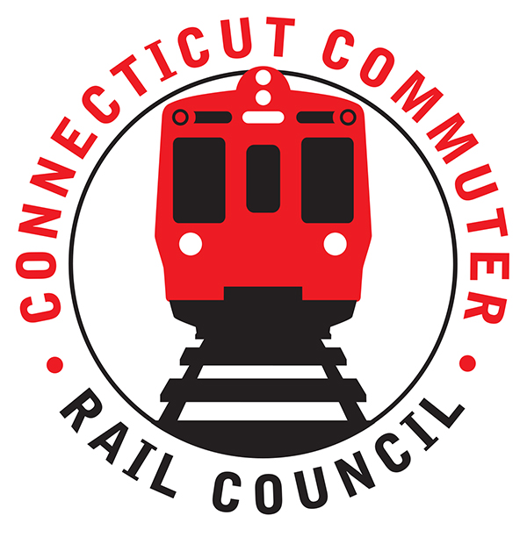

**Connecticut Commuter Rail Council**

**August 28, 2019**

**Valley Transit District**

**Meeting Room**

**12 Main Street**

**Derby, CT 06418**

**(Next to Derby Train Station)**

The following Council Members were in attendance: Jim Gildea, Sue Prosi, Melissa Kane, Lisa Slinsky, Peter Garneau, Doug Hausladen, and Roger Cirella.

The following people were in attendance: Representative Kara Rochelle, Ansonia, CT; George S. Logan, CT State Senate, David S. Cassetti, Mayor of Ansonia, CT; Thomas Allen, Representing Senator Blumenthal; Ron Napoli, Waterbury State Representative; Mark Demac, Office of Mayor O’Leary; Gabe Filer, Middletown (NVCOG); David Tusio, U.S. Senator Murphy Representative; Ben Cornelius, Metro-North; Mike Donnarumma, Metro-North; Rich Andreski, CDOT; Rich Jankovich, CDOT; Glenn Hayden, Metro-North; Carl Jackson, CDOT; Dave Keating; Roger Senserrich; Robert Hale; Donna Collins; Dashell Farrow; June Weaver, Chris Minutolo; Jennifer Coe; Mark Nielsen, Agnes Rawlins-Maynes; Anika Rawlins; Benni Kavanaugh; Neil Cameron; Shannon Crowley; Leslie Navarette; Bill Dobbins; Tom Wood; Josh Shuart; Monina D. Manuel; and Gail Bournivak.

The July 2019 minutes were approved.

Public Comments: None.

Council Business:

1. **Commissioner Joseph Giulietti Branch Overview and Rail Discussion**.

Rich Andreski said the plan is to double rush hour service on the Waterbury Line. Additional equipment will be required to expand service. CDOT may go it alone or team up with Metro-north to procure additional rail cars. Rich Andreski said it makes sense to go with MTA.

A question was asked about having service comparable to the Danbury Line. Glenn Hayden said the infrastructure being installed on the Waterbury will be similar to the Danbury Line.

Representative Rochelle asked about the schedule. Rich Andreski said we are going to need substantial, additional funding to expand service.

A question was asked about speeding up the project. The reply was that Metro-north resources are thin and the project cannot be speeded up.

Rich Andreski said that CDOT will work on better communication and better management of service for commuters.

There will be a six (6) week outage on the Waterbury Branch in early April 2020 and weekend outages next summer to accommodate work on the Waterbury Branch.

1. **Passenger stranding incident 8/4 discussion**.

Some trees came down on August 4th. There was a switch issue. As a result, service had to be suspended. Fortunately, there were no major medical issues. Jim Gildea asked where the conductors were, when all this was happening. Apparently, the conductors retreated. Metro-north said passengers usually have more information than the conductors. In the future, there will be a system that will send information to commuters when these incidents occur.

1. **Passing siding and Branch PTC-update and progress**.

Rich Andreski said that Beacon Falls is scheduled for a siding installation this year. The 12/20 deadline for PTC is being pushed out to 12/21. Additional rail service would not start until at least 2022.

1. **Let’s Go CT-Branch Locomotive and Coach upgrades**.

New rail cars for the Branch are at least five (5) years out. There is a possibility of obtaining used cars from other states such as California. The locomotives on the Branches are currently being overhauled. Currently, there is no funding for an additional fifty (50) rail cars that the Branches need. There is two hundred fifty (250) million dollars appropriated for sixty (60) rail cars.

1. **Main Line Issues-questions for MNR**.

Metro-north said it was a rough month. There were three (3) instances with signal power issues. Funding has been identified for tree clearing.

1. **Branch Line Issues-questions for MNR**.

Ties are scheduled to be replaced on the Danbury Line . Buses will be replace trains on the Waterbury Branch from September 20th-October 6th.

Adjourned at 8:31pm.

Respectfully submitted,

Roger J. Cirella, Secretary